6 July 2012
KANATA BEAVERBROOK COMMUNITY ASSOCIATION (KBCA) POSITION ON
1131 TERON ZONING BY-LAW AMENDMENT APPLICATION D02-02-12-0041

This Position Statement being submitted by KBCA consists of three parts:
PART I
KBCA Review of 1131 Teron
Part I was prepared by KBCA representatives, and identifies issues of concern as well as potential legal problems which will be discussed and confirmed with the KBCA lawyer and expert planner.
PART II
Review of the Policy and Regulatory Framework which views the compatibility of the proposal for 1131 Teron against the Official Plan and Comprehensive Zoning By-Law policies
This part of the submission was also prepared by KBCA representatives and draws upon information and advice previously provided by expert planner Dennis Jacobs who would evaluate for consistency and sound application upon return from vacation.
PART III
Review of Beaverbrook Concepts and Character
This part also considers the regulatory policies within their context, for 1131 Teron.
This part also contains an Appendix which discusses and illustrates Beaverbrook Design and Architecture.

PART I KBCA REVIEW OF 1131 TERON
DR Land Adjacent To March Road is Designated Employment Area In OP Schedule B
The Planning Rationale Pg 11 indicates that part of the DR parcel is not designated General Urban Area:
A portion of the Subject Property immediately adjacent to March Road, and coinciding with where the hydro easements are located is designated Employment Area on Schedule B: Urban Policy Plan, and included as Exhibit
“D”. The lands are not intended for development consistent with the terms of that easement thus the policies of that designation are not relevant.
The portion of the Subject Property where the structures are proposed is designated as General Urban Area as shown in Exhibit “D”, which is Schedule “B” from the City’s Official Plan.
The developer appears to be making these statements to avoid the Employment Area (EA) policies by indicating that the easement agreement (this should be plural) can make the EA policies irrelevant.
It should be noted that agreements for easements cannot legally override the OP designation or the requirement to meet the associated Official Plan (OP) policies.
While the OP designation sets specific polices and may apply to part of a property, the Comprehensive Zoning By-law (CZBL) provides for specific properties to be zoned with one land use designation.
The OP indicates that this should be accomplished by division of land:

Official Plan Section 3 - Designations and Land Use
A land-use designation describes an area of land within which a specific set of policies applies.
A land-use designation in an official plan is implemented through a range of more detailed land-use zones in a zoning by-law. While the zoning by-law is more detailed, it must conform to the policies in the official plan. The official plan also directly influences the division of land through plans of subdivision or by severance.

When the DR parcel was designated in the 1988 and 1997 regional official plans, the property was totally in the General Urban Area designation and was zoned as RH Residential Holding in the corresponding zoning by-laws. This was changed to DR Development Reserve in the CZBL harmonization process. In the 2003 Official Plan, however, the Employment Area designation was placed on the hydro corridor portion of the DR parcel and other properties along March Road abutting the Bethune development.
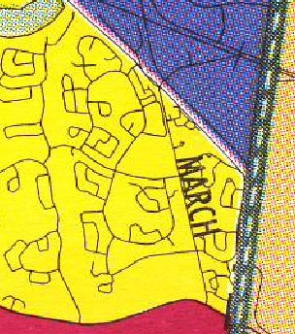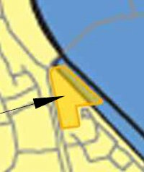
1997 Regional OP Schedule B 2003 OP Schedule B
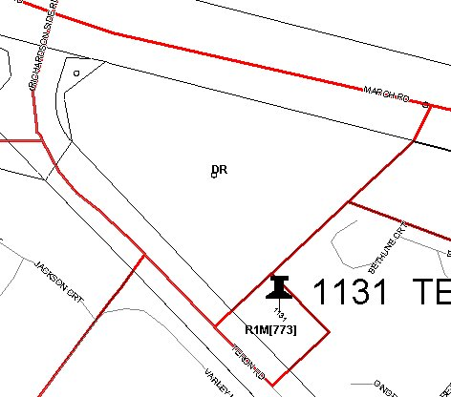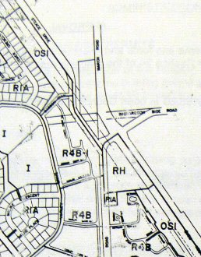
eMAP Beaverbrook ZBL 55-95

This split of the property into 2 OP designations may create a problem for the current zoning application as the DR parcel now has two sets of governing policies which need to be met. The Employment Area portion is governed by Section 3.6.5 – Employment Area and Enterprise Area, which states:
Employment Areas are designated to enable a variety of functions:
- Noxious industrial uses that impose constraints on other uses locating nearby and require a buffer between these and other uses;
- Uses that, while not noxious, are incompatible with other uses because of noise, lights and around the clock operation, etc.;
- Prestigious uses (usually office or combinations of office/clean industrial) with a signature address and a desire to locate among other similar uses.
The decision to designate land as an Employment Area will be determined, in part, by its ability to accommodate at least 2,000 jobs. They will have various locational attributes depending on the type of Employment Area such as key locations on 400 series highways and multi-lane arterials; and locations that have good truck or rail or air access. These are also areas that can provide large parcels of land at affordable prices. Because one of the objectives of this Plan is to balance housing and employment opportunities in all urban communities outside the Central Area, lands designated as Employment Areas are distributed throughout the urban fabric, with at least one in each urban community outside the Greenbelt boundary.
The ZBA application proposes that the DR parcel be designated R5, however, it appears that this may be in conflict with the Employment Area in OP Section 3.6.5, which does not appear to support residential designations. The hydro corridor portion is unlikely to ever be developed. The developer uses this “Employment” area in the Concept Plan to give the impression that the land will be improved to provide pathways and greenspace for the residents and others. Whether the 2 hydro companies will allow this use is uncertain.

The CZBL does not appear to have a specific section for Employment Area, however, the most likely designation would be in Section 11 IP – Business Park Industrial Zone (Section 205-206) due to the proximity to the Kanata Industrial Park.

The CZBL Section 8 description for the O1 – Parks and Open Space Zone (Sections 179-180) designation appears to be restricted to the General Urban Area designation and does not appear to mention open space in Employment areas, however, the other parts of this EA land were zoned Open Space prior to the 2003 OP which changed the GUA to Employment Area. KBCA would encourage the City to identify the alternatives for providing an Open Space designation on the EA land to ensure compatibility with the EA strip adjacent to the Bethune development which the CZBL designates as O1 Open Space.

It is KBCA’s Position that it is inappropriate to zone the hydro corridor as R5 if this is not permitted in the Employment Area and when other segments of the corridor are zoned as Open Space, particularly when the developer is proposing landscaping for the ”public realm”.

Designation of the land as Open Space also raises issues as to land ownership and responsibilities for creating the public realm, if this is allowed by the hydro companies.
The GUA/EA issues should be resolved prior to this ZBA being approved.
The hydro companies should be approached to determine exactly what will be permitted on the DR parcel.
KBCA is particularly concerned that the City may have removed the land from Beaverbrook with no notice.

Separate Parcels Require Separate Zoning Provisions
The developer has proposed a Planned Unit Development (PUD) to sit on both the R1 and DR parcels, however, the PUD definition says that the units must be on one lot. The Planning Rationale Pg 23 states:
The proposed use for the development of the Subject Property is considered as an “apartment building, mid-high rise” and “multiple attached dwelling” in a “planned unit development’ built form. These are not listed as permitted uses in either zone and thus a Zoning By-law amendment application is required.
The definition of these uses is as follows;
“Planned unit development” means two or more residential use buildings on the same lot
The R5 - Residential Fifth Density Zone, with suggested exceptions, is appropriate for the Subject Property
The CZBL R5 - Residential Fifth Density Zone (Sections 163-164) Zone Provisions rely on the PUD being on one lot, as stated:
(4) Where a planned unit development is permitted on a lot in the subzone, the provisions of Section 131 apply, and the associated subzone provisions identified in Table 164 A affecting permission of uses, minimum lot widths and lot areas, as well as minimum required setbacks apply to the whole of the lot, while the maximum height applies to each permitted dwelling type within the planned unit development
CZBL Section 93 One Lot for Zoning Purposes does not appear to be applicable to these parcels as there is no provision for this within Residential Zones:
A group of occupancies located in an AM – Arterial Mainstreet Zone, GM – General Mixed-Use Zone, LC – Local Commercial Zone, MC – Mixed-Use Centre Zone, MD – Mixed-Use Downtown Centre Zone, IG – General Industrial Zone, IH – Heavy Industrial Zone, IL – Light Industrial Zone, or IP – Business Park Industrial Zone that: ....
CZBL Section 131 Planned Unit Development appears to conflict with Section 93 One Lot for Zoning Purposes in that it allows a PUD, which by definition must be on one lot, in the R3 and R5 designations, however, there are restrictions, as stated:
 | 1) Planned unit development is permitted only if:
 |  | (a) | it is in a zone or sub-zone in which a planned unit development is a permitted use;
 |  | (b) | it consists only of uses that are permitted in the zone or sub-zone; and
 |  | (c) | the entire planned unit development complies with all applicable Sections of the By-law, the provisions set out in this Section and Table 131, however, any development parcels within the planned unit development that are severed need not comply with the dwelling type-specific provisions indicated in Part 6 other than maximum permitted building height.
The developer’s application, which requests exceptions, does not comply with all applicable sections of the By-Law, and is incomplete due to the failure to address these relevant zoning provisions. The CZBL also sets an impossible condition in (1)(c) by indicating that the maximum permitted building height must be met, then negating this by Note 51 which states “Maximum building height is either shown with an H(#) on the Zoning Map, on a Schedule or in the exception zone”, making it discretionary for high-rise apartments.
The proposed apartment and multiple attached dwellings are not on the same lot and have separate zoning. It is KBCA’s understanding that as long as there are 2 parcels, the PUD requirement for 1 lot cannot be met, and that the setbacks and other zoning requirements should be considered for each of the separate properties.

Given that the R1 parcel is separate, the R3 designation is more appropriate for the property and proposed use.
Should the R5 designation be approved, it should be noted that the elevator utility attached to the multiple attached units is only permitted in Apartments in this zone, as stated in the R5 provisions in Section 163 (11):
Utility installations are permitted:
(a) only in an apartment dwelling, mid-high rise, an apartment dwelling, low rise, a retirement home, or a building containing more than one principal use ...

DR Zoning
The Planning Rationale Pg 21 describes the purpose of the DR zone:
By-law 2008-250 outlines the purpose of the DR zone as follows;
(1) recognize lands intended for future urban development in areas designated as General Urban Area and Developing Communities in the Official Plan, and future village development in areas designated as Village in the Official Plan;
(2) limit the range of permitted uses to those which will not preclude future development options; and
(3) impose regulations which ensure a low scale and intensity of development to reflect the characteristics of existing land uses.
Pg 38
6.3 Conformity with Comprehensive Zoning By-law 2008-250
The existing DR zoning is intended to recognize future urban
Pg 39
development opportunities in areas designated as General Urban Area.
The proposed amendment to an R5 subzone would be appropriate for the site.
In fact, Council has recently approved other DR parcels which have respected the character of the neighbourhood by requiring R3 zoning. The developer provides no reason why the proposed R5 zoning would be appropriate for the site, or why the R5A sub-zone is the most appropriate.

Greenfield Policies Are Not Addressed
DR parcels are considered as “greenfield”, however, the Planning Rationale fails to indicate that the DR parcel is subject to Official Plan greenfield policies and intensification targets and that the R1 parcel is subject to the “unforeseen redevelopment” policies.
The Residential Land Strategy for Ottawa 2006-2031, which was used as the basis for the Official Plan, Figure 51 on Pg 70 indicates that only 563 Apartment units and 3.8 net hectares are required to 2031 for greenfield developments and the Greenfield Units table on Pg 94 indicates that only 94 Apartment units are required in 2012, for the entire urban area land outside the Greenbelt. Placing 173 apartment units in 1 location within Beaverbrook is inappropriate, particularly when the City has not identified specific locations for those greenfield apartments and when placing them in Beaverbrook detracts development from the other greenfield areas which are more appropriate.
The Residential Land Strategy also states:
Pg 8
- Permit high-rise buildings in the Central Area, Mixed-Use Centres and Town Centres.
- Acknowledge intensification potential outside the target areas and accommodate it subject to urban design and building height requirements that preserve neighbourhood character and do not detract from the target areas’ ability to be the focus of intensification and growth within the built-up area.
- On greenfields outside the Greenbelt, establish a minimum net density of 26 units per hectare for all new single detached dwellings, and a minimum overall residential net density of 32 units per hectare.
Pg 70
Net residential densities on greenfields will be measured on a subdivision-by-subdivision basis.

The first statement supports the KBCA position that the 1131 Teron proposal needs to meet building heights that preserve the low-rise character of Beaverbrook, and that high-rise buildings belong in the Kanata Town Centre.
It appears that the 1131 Teron development is required to be treated as a subdivision for measurement against the density requirements.
The developer’s application is incomplete in that it has failed to address the relevant Official Plan Greenfield policies. The proposal does not meet the “building height requirements that preserve neighbourhood character” and the proposed density of 121 units per hectare (based on 170 units on 1.48 hectares) far exceeds the Greenfield density target.
It should be noted that both the Provincial Policy Statement and the Residential Land Strategy refer to intensification and redevelopment as being separate and the Official Plan further separates Greenfield and infill requirements. The proposed development is not “Infill” and there are no apparent targets for “redevelopments”. Because of this, many of the statements extracted by the developer from the OP to support the zoning application are not relevant.
It should also be noted that there are logic problems with the Greenfield policies in that 1131 Teron is located “beyond the Greenbelt” but the description for existing neighbourhoods within the Greenbelt is applicable. Analysis of the Urban Design Guidelines for Greenfield Neighbourhoods indicates the following:
Page 4 Types of Greenfield Neighbourhoods
located in designated Urban Areas beyond the Greenbelt | located among existing neighbourhoods, within the Greenbelt.
usually large, usually undeveloped, | generally smaller in size than those beyond the Greenbelt
face issues of scale, phasing, compatibility as well as sensitivity to environmental carrying capacity, and natural and cultural features. | given they are typically located in the midst of existing neighbourhoods, issues of connections, transition and compatibility are often at the forefront.

The logic for this is 4 part:
 | Beyond the Greenbelt |  | Within the Greenbelt
 | Guidelines | 1131 Teron | Guidelines | 1131 Teron
Location | Yes | Yes | Yes | No
Neighbourhood exists | No | Yes | Yes | No
Logic is missing for 1131 Teron Beyond the Greenbelt + Existing Neighbourhood.

OP Compatibility – 40% Townhouses and Apartments
The Planning Rationale Pg 10 implies that 1131 Teron should be approved because OP Section 2.1 requires 40% of the housing outside of the Greenbelt to be townhouses and apartments, as stated:
The City’s Growth Management Strategy is illustrated in Section 2.1, with the following opening statement being of critical importance;
Almost two-thirds of the added housing stock will be located outside the city’s Greenbelt.
Many of the new dwellings there will be in the form of single-detached homes, but at least 40 per cent will be either townhouses or apartments
The developer fails to indicate that the Residential Land Strategy for Ottawa 2006-2031, which is the basis for the Official Plan, states in a footnote on Pg 83 that the apartments required are stacked townhouses:
Net land requirement (ha) Gross land requirement (ha)
to allow for 40% townhouses and apartments:
Rows * 112.6 225.2
Apartments * 3.8 7.6
* land requirement based on 5,067 townhouses and 563 apartments (stacked townhouses)

The developer should be building row houses as these have a significant number required and would be more compatible with the adjacent properties and Beaverbrook character.
OP Compatibility – 32,000 Units
The Planning Rationale pg 10, following reference to OP Section 2.1, states:
Figure 2.2 suggests the need for 32,000 new households in the outer Greenbelt urban areas from 2011 to 2021. The Subject Property is so located.
No such figure was located in the OP for the urban area. There is, however, 32,000 households identified for the Rural area. The Residential Land Strategy for Ottawa 2006-2031, which is the basis of the 2031 Official Plan, has no such “32,000” in the pg 64+ Appendix 3 - Annual Projections of Dwelling Units By Type and Location, and states on Pg 82:
Projected Greenfield Households by type
The balance of urban dwellings projected to 2031 when intensification dwellings are removed
Singles 43,397 54%
Semis 4,976 6%
Rows 28,712 36%
Apartments 3,467 4%
Total 80,552

Landmark/Gateway
The developer has failed to address the Urban Design Guidelines for Greenfield Neighbourhoods Pg 24 Guideline 36 which states:
Design buildings at key intersections as “landmark buildings”, with enhanced height, massing, building projections, architectural elements, and public space.
Figure 36a provides a 4 storey sample which is said to “reinforce the prominence of these key locations and contribute to a sense of place and identity.
Figure 36b shows 4 buildings centred around the intersection and states:
Landmark sites should be the focus of more intensive development and have a greater mix of uses than other locations.

The 1131 Teron Apartment building on the DR parcel is not located at the intersection, the intervening hydro easement prevents more intensive development, and the proposal does not provide a greater mix of uses within the parcel.
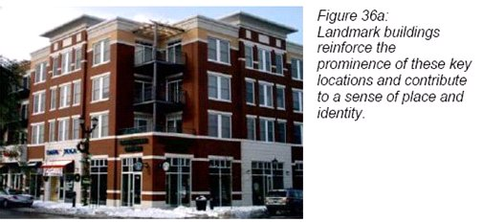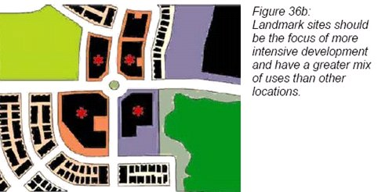

Stepping And Transition Of Buildings
The developer has failed to address the Urban Design Guidelines for Greenfield Neighbourhoods Pg 13 Guideline 15, which states:
Create a transition in height from taller buildings to adjacent lower buildings, particularly when connecting to an adjacent development or neighbourhood.

Figure 15a states:
Tapering of heights and intensity between high-rise and low-rise dwellings should be planned from the outset

Figure 15b states:
A progression in heights from high-rise to low-rise buildings is an important element in limiting the impact of sun shadowing and in the acceptance of higher densities

The 1131 proposal has only considered the transition to the Bethune condominiums and has not considered the Beaverbrook Lane, Jackson Court and Varley Lane transitions.

Stepping the buildings in a 3-10-15 pattern would have been more appropriate than the proposed 3-15-10 pattern.
The 1131 proposal also is not compatible with the heights of buildings in the Industrial Park.

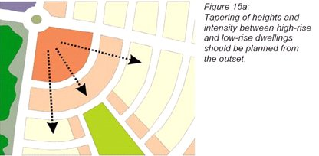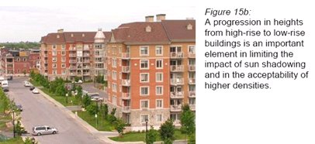

OP Compatibility – Eventual Location of Rapid Transit Station
In the Planning Rationale Pg 18 under OP Section 4.11 the developer claims that 7c “high-rise” and 9b “600m from RTS on Schedule D” justify the proposed development:
7. The following guidance is provided as a guide for the preparation of secondary plans and community design plans, and for consideration when reviewing development applications:
c. High-Rise – a building 10 storeys or more.
9. In addition to provisions in policy 8 above, high-rise buildings may be considered in the following locations, provided all other policies of this Plan have been met:
b. Within 600 metres of a rapid transit station as identified on Schedule D,
The proposed development, in part, would be considered as meeting 7.c. and 9.b. and thus the Subject Property is a candidate for the proposed development scheme.
There is no “test” in Policy 7 – this is just a descriptive statement. The developer does not meet any of the tests in Policy 8 which identifies target areas. The first test in Policy 9b is that the development be within 600m of a rapid transit station. The second part of the test is that this rapid transit station be identified in OP Schedule D.
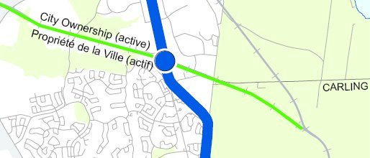
OP Schedule D extract
In fact, the only rapid transit station identified in Schedule D appears to be north of Carling Avenue, not at the Teron Road/March Road intersection as claimed in the Planning Rationale Pg 20, which states:
As stated above, the Subject Property is located within 600 metres of a planned rapid transit station. This is illustrated on Exhibit “F” which is Schedule “D” of the Official Plan. Staff has indicated that the eventual location will likely be at the Teron/March Road intersection. This meets the criteria for consideration of highrise as per Section 4.11.9. b).
Exhibit F aka Schedule D does not illustrate this as claimed. City staff informing the developer of the “eventual location” does not override Section 4.11.9b. In addition, City staff informed the public at a recent public meeting that while a station (which is actually just a covered shelter) may be located at Teron/March, this will not happen for 15 to 20 years, to which the Ward Councillor, who is chair of the Transportation Committee, replied “or even later”.

Property Size Conflicts and Missing Information
Most of the 1131 Teron reports indicate that the property is 1.48 hectares, however, the Phase 1 ESA
Pg 6 says the area is 3.82 acres – if this is correct – it equals 1.54589 hectares. Comparison of the R1 and DR parcels to other properties on the Site Servicing Study Pg 36 map indicates that the property may exceed 2 hectares.
The supporting documents are missing a great deal of information, e.g. there is no illustration or quantification of developable lot size, building footprint area, landscaped area (which should not include the at grade terraces or the DR parcel), GFA, final building heights, final underground parking garage depth, etc., for at least the developable portion, all of which are required for the City and the public to evaluate the proposal.

Of particular concern is whether the landscaping area percentage meets the requirements of the CZBL

R5 - Residential Fifth Density Zone (Sections 163-164) Zone Provisions, which state:
(9) Thirty percent of the lot area must be provided as landscaped area for a lot containing an apartment dwelling, mid-high rise; apartment dwelling; low rise, stacked dwelling; retirement home, or a planned unit development that contains any one or more of these dwelling types (By-law 2008-341).
The developer’s reports appear to rely on the DR hydro corridor land and the at-grade terraces.
Given that the developer has not provided the percentages for landscaped area, analysis of the Concept Plan was undertaken by KBCA which shows that, excluding the terrace areas which are not to be considered part of this space, and including all the land in the developable area up to the sidewalk, the percentage appears to be about 20%. It should be noted that the Beaverbrook concepts and zoning by-laws required considerably more landscaped and greenspace, ranging up to 40% and that this was calculated on the required larger lot sizes resulting in a more proportionate amount of greenspace.

The developer should be required to provide this information to the public prior to the preparation of the Staff Report.

Errors and Omissions in the Servicing Study
KBCA finds the Servicing Study to be of extremely poor quality. It is of major concern that the developer’s consultant used boilerplate text that confused 1131 Teron with 405 Tweedsmuir and makes reference to Ottawa Centre and Ottawa South. The servicing study should be redone before any approvals of the development are given and the study should meet the standards of other development applications.
Likewise, the 9 page Geotechnical Report (6 pages of which constitute the text) does not meet the standards of other development applications observed to date. For example, the geotechnical investigation for 1025 Canadian Shield Avenue for a 10 storey apartment is 51 pages, of which 30 are the main report.
The reports, in particular the Traffic Study, are confusing and contain errors due to the failure to establish descriptive standards for the N-S-E-W directions.
While KBCA understands that the City relaxes the requirements for small landholdings, this is generally intended to provide financial relief for landowners who are building small structures. Landowners who are expecting to build 15 storey high-rises and reap millions in profits should be providing full reports appropriate to the size, scale and impact of their buildings.

PART II REVIEW OF POLICY AND REGULATORY FRAMEWORK
The subject property is located at 1131 Teron Road, Kanata on Teron Road. The site is currently occupied by a one storey house which was zoned for use as an office in 2001. This building is located on the R1 parcel and DR parcel is undeveloped land which includes 2 hydro easements. The site is adjacent to a low-rise neighbourhood and is surrounded by the Bethune townhouse condominium, the Jackson Court townhouse condominium and the Varley rental townhouses.
The application is to rezone the 2 parcels from R1 to R5A to permit 6 three-storey townhouses and from DR to R5A to permit a 15 and 10 storey 173 unit high rise apartment, creating a total of 179 units.
Summary Opinion
It is the opinion of the Community that the application for 1131 Teron should be refused as it does not conform to the policies of the Official Plan, in particular Section 2.2.2 Managing Growth Within the Urban Area; Section 2.5.1 Urban Design and Compatibility; Section 3.6.1 General Urban Area and Section 4.11 Urban Design and Compatibility . Further, it is our opinion that said By-law permits a height, form and mass of development that is not good planning or compatible development for the subject property given the neighbourhood context and creates the potential for causing undue adverse effects under the intent and purpose of these and other sections of the Plan.
This report focuses on two key issues which are fundamental to determining the appropriateness of the proposed development and the assessment of its conformity and compatibility as defined in the Official Plan and related policy documents. These issues are:
- maximum building height
- density and applicability of intensification policies.

Official Plan
Section 2.2.2 Managing Growth Within the Urban Area is part of the strategic directions for the Official Plan and as such provides an overall strategy and context for the consideration of intensification. The Official Plan is predicated on an approach best described as ‘nodes and corridors’ which are areas targeted for more intensive growth. One such condition for a "node" is the presence of a transit station which may or may not be built close to the said site. However, we believe that, while a necessary condition for a node, it is not a sufficient condition. This potential future BRT transit station will be principally a load-unload point for workers in the immediate vicinity surrounded by industrial activity and has no potential to become a pedestrian-friendly core that is intended when permission for high rise buildings is given.
The subject property is thus not located in one of these targeted areas and therefore is subject only to general support for intensification and only in a manner which is compatible with the neighbourhood character. As a result, the following excerpts from the Official Plan provide general guidance for considering appropriate levels of intensification:
“Consequently, within the designated urban area, growth will be directed to locations with significant development potential, specifically those designated as Central Area, Mixed-Use Centres, Employment Areas, Enterprise Areas, Developing Communities and Mainstreets. These areas include locations that are centred on the rapid-transit network, major roads, busy commercial streets, and large tracts of vacant land.”

“Within lands designated General Urban Area, opportunities for intensification exist and will be supported, although such opportunities are generally at a much smaller scale than in the land-use designations described above.”
“The quality of the built environment is a significant cornerstone of intensification. Well-designed public spaces and buildings are considered to be critical factors in achieving compatibility between the existing and planned built form. This Plan requires that intensification proposals have full regard for the existing built context and a full understanding of the impacts the proposal will have on both the immediate and wider surroundings. Consequently, this Plan calls for excellence in urban design and architecture, both in the public and private realms.”
Thus while intensification is to be supported in the General Urban Area, the most important factor to consider is the neighbourhood context and compatibility. It is the Community’s opinion that the development as proposed represents overdevelopment and is not compatible. It proposes a significant increase in the number of dwelling units in a building height, form and mass which is not sympathetic to, nor supportive of, the existing neighbourhood character. The rapid transition from 3 to 15 stories with minimal setback from Teron Road is not in character with the neighbourhood of 2 storey townhouses.
Section 2.2.2 continues with policies related to intensification outside targeted areas as follows:

“Intensification Outside of Target Areas
- The City also supports intensification throughout the urban area, including areas designated General Urban Area. The City will promote opportunities for intensification in the following cases, provided that all other policies in the Plan are met:
  - Lands within 600 metres of future or existing rapid-transit stations with potential to develop as compact, mixed-use and pedestrian-friendly cores;
  - Lands that are no longer viable for the purpose for which they were intended, such as older industrial areas, exhausted quarries, or abandoned transportation corridors that are not planned for open space or designated as Recreational Pathways, but does not include lands designated as Employment Area or Enterprise Area where the proposal for intensification or infill would introduce uses not otherwise permitted by this Plan; (School sites are generally not included in this category and will be treated on a site-specific basis); [OMB decision #2649, September 21, 2006]
  - Lands where the present use is maintained but the addition of residential uses or other uses can be accomplished in a complementary manner, such as on under-utilized shopping centre sites;
  - Lands currently or formerly used as parking lots or other extensive storage purposes;
  - Lands where records indicate existing contamination due to previous commercial or industrial use, but which can be made suitable for development if cleaned up.
[Amendment #76, OMB File # PL100206, September 07, 2011]

The interior portions of stable, low-rise residential neighbourhoods will continue to be characterized by low-rise buildings (as defined in Section 4.11, policy 7). The City supports intensification in the General Urban Area where it will enhance and complement its desirable characteristics and long term renewal. Generally, new development, including redevelopment, proposed within the interior of established neighbourhoods will be designed to complement the area's pattern of built form and open spaces.
As a Community, it is certainly our opinion that the subject site does not fit under any of the criteria noted in Policy 13 and so should not be considered as a target for increased intensification. As well, the site is considered interior to the overall community of Beaverbrook due to its close proximity to the adjacent townhouses which surround it on Teron Road. As such, any consideration of intensification must be directed by Policy 14 and it is our opinion that this proposal does not conform due to its height, form and mass.
It should also be noted that as a high rise building it would be subject to additional policies such as the following under Section 2.2.2:
“18) Policies on where high-rise buildings may be considered are found in Section 4.11 of this Plan.” [Amendment #76, OMB File # PL100206, September 07, 2011]
With the exception of the hydro corridor, the site is designated as General Urban Area under Section 3.6.1 of the Official Plan. This designation permits a wide range and choice of housing types as well as many of the employment and service needs of the community. Due to its broad permissions, the zoning by-law is the primary tool for managing change within the designation. With respect to infill and intensification, it states ‘Subject to the policies below, the City supports infill development and other intensification within the General Urban Area in a manner that enhances and complements the desirable characteristics and ensures the long-term vitality of the many existing communities that make up the city.
Policies
3. When considering a proposal for residential intensification through infill or redevelopment in the General Urban Area, the City will:
a) Recognize the importance of new development relating to existing community character so that it enhances and builds upon desirable established patterns and built form;
b) Apply the policies of Section 2.5.1 and Section 4.11;
It is the opinion of the Community that the current proposal 1131 Teron does not relate to the existing community character as it introduces a building height and form which is inconsistent and should not be approved. It also does not build upon what we feel are the desirable established patterns as outlined in the previous paragraphs. Looking further at the Official Plan in Section 2.5 Building Liveable Communities we find the following in the 3rd paragraph: ‘”A focus on community design draws attention to how buildings and the spaces around them look and function in their setting. Since the best urban design is informed by a solid appreciation of the place being built, the people in it, and the community around it, this approach opens the door to creativity and dialogue.” [Amendment 28, July 13, 2005]. It is the opinion of the Community that this proposal has not ‘been informed by a solid appreciation’ of the area and should be refused.
Section 2.5.1 Urban Design and Compatibility further defines how to assess compatibility and design. This section of the Official Plan provides the overall direction for assessing neighbourhood compatibility. The following excerpts provide the context for the assessment of these criteria:
Introducing new development in existing areas that have developed over a long period of time requires a sensitive approach and a respect for a communities established characteristics. This Plan provides guidance on measures that will mitigate these differences and help achieve compatibility of form and function. Allowing for some flexibility and variation that complements the character of existing communities is central to successful intensification.
In general terms, compatible development means development that, although it is not necessarily the same as or similar to existing buildings in the vicinity, nonetheless enhances an established community and coexists with existing development without causing undue adverse impact on surrounding properties. It ‘fits well’ within its physical context and ‘works well’ among those functions that surround it. Generally speaking, the more a new development can incorporate the common characteristics of its setting in its design, the more compatible it will be. Nevertheless, a development can be designed to fit and work well in a certain existing context without being ‘the same as’ the existing development.

It is the opinion of the Community that the proposal is not sensitive to the community and its characteristics and due its height, form and mass does not fit well or work well in the site context. Finally, while the townhouses are an attempt by the developer to match the existing 2 storey townhouses, the proposed 3-storey townhouses are much taller due to the underground parking lot and the proposed high rise apartment does not incorporate any common characteristics and therefore the proposal should be refused.
The next comments are also from Section 2.5.1 Urban Design and Compatibility and provide more direction on how to achieve compatibility.

“Design Objectives
- To enhance the sense of community by creating and maintaining places with their own distinct identity.

Principles:
Design should:
- Support the overall image of Ottawa as the Nation’s capital.
- Recognize and reflect on the history of the city or community.
- Promote quality consistent with a major metropolis, and a prime business and tourist destination.
- Create distinctive places and appreciate local identity in patterns of development, landscape and culture.
- Reflect a thorough and sensitive understanding of place, context and setting.
- Consider public art early in the design process and integrate it, as appropriate, as part of the project.
- To define quality public and private spaces through development
Principles:
Design should:
- Clearly define and connect public and private spaces by:
  - Defining and enclosing spaces using buildings, structures and landscaping.
  - Recognizing every building as being part of a greater whole that contributes to the overall coherency of the urban fabric.
- Enhance and enliven the quality, character and spatial delineation of public spaces.
- Consider streets as public spaces.
- Encourage a continuity of street frontages. Where continuous building facades are not a dominant feature of the streetscape, the gradual infilling of empty spaces between buildings and between the building and the street edge is promoted to occur over time. Depending on the stage of evolution of the street, it may be appropriate to achieve this principle in a number of ways e.g., building form, landscape treatment, architectural ornamentation.
- Address the relationship between buildings and between buildings and the street.
- Meet the needs of pedestrians as a priority.
- Contribute to attractive public spaces and important vistas.
- Minimize the exposure of inhabitants to noise levels that could adversely impact their health and well-being.
- Reduce the visual impact of infrastructure, public utilities, or street furniture by clustering or grouping them where possible, whether located within the public right-of-way or on private property. [Amendment #76, OMB File #PL100206, August 18, 2011
- To create places that are safe, accessible and are easy to get to, and move through.
Principles:
Design should:
- Connect buildings and spaces through a network of roads, sidewalks, and pathways in ways that are understandable. These connections should be accessible to all users and incorporate the principles of universal access and where connections lead into a building, the building and its facilities should be designed so that it can be approached, entered, and used by persons with physical or sensory disabilities.
- Integrate public transit with existing and new development, where feasible.
- Provide appropriate (i.e., size and placement) signage identifying pathways, intersections and landmarks.
- Create places and spaces that are visible and safe and can be confidently used at all hours of the day and at night where it is appropriate to do so.

- To ensure that new development respects the character of existing areas.
Principles:
Design should:
- Integrate new development to complement and enliven the surroundings.
- Allow the built form to evolve through architectural style and innovation.
- Complement the massing patterns, rhythm, character, and context.
- To consider adaptability and diversity by creating places that can adapt and evolve easily over time and that are characterized by variety and choice. [OMB decision #2649, September 21, 2006]
Principles:
Design should:
- Achieve a more compact urban form over time.
- Provide flexibility for buildings and spaces to adapt to a variety of possible uses in response to changing social, economic and technological conditions.
- Allow for varying stages of maturity in different areas of the city, and recognize that buildings and site development will exhibit different characteristics as they evolve over time.
- Accommodate the needs of a range of people of different incomes and lifestyles at various stages in the life cycle.
- To understand and respect natural processes and features in development design
Principles:
Design should:
- Protect the City’s natural heritage system and take an ecosystem approach to design that supports natural functions, such as natural drainage, groundwater recharge and discharge, and wildlife habitat.
- Protect, integrate and enhance the urban forest, vegetative cover, green spaces and corridors, environmental features and landscapes, and existing topography, where possible and appropriate.
- Demonstrate that all practical means of retaining stormwater on site have been considered.
- Reduce the release of contaminants into the environment.
[Amendment #76, Ministerial Modification #9, OMB File #PL100206, August 18, 2011]
- To maximize energy-efficiency and promote sustainable design to reduce the resource consumption, energy use, and carbon footprint of the built environment.
It is the Community’s opinion that the proposal does not satisfy these design objectives, in particular with respect to the underlined sections and as a result should be refused.

Section 4.11 Urban Design and Compatibility is found in the part of the Official Plan that provides guidance in the review of development applications. The following paragraphs are relevant to the issue of compatibility:

- First Paragraph - ‘Locational policies are therefore required in order to direct uses that have the potential to generate negative impacts to appropriate locations, most typically at the periphery of residential neighbourhoods. It is recognized that because land use designations such as General Urban Area, Mainstreets and Employment Area contain broad use permissions, it will be necessary for the zoning by-law to establish more specific permitted use lists and development regulations within areas and on individual sites in a manner that achieves compatibility among proximate uses and built forms.’

- Second paragraph – ‘At the scale of neighbourhoods or individual properties, issues such as noise, spillover of light, accommodation of parking and access, shadowing, and micro-climatic conditions are prominent considerations when assessing the relationships between new and existing development. Often, to arrive at compatibility of scale and use will demand a careful design response, one that appropriately addresses the impact generated by infill or intensification. Consequently, the issue of ‘context’ is a dominant theme of this Plan where it speaks to compatibility and design.’

- Fourth paragraph – ‘However, compatibility may be more difficult to achieve in other situations. To achieve the Plan’s strategic directions for managing growth, the zoning in many areas of the city, particularly areas adjacent to major roads, at the periphery of neighbourhoods and proximate to transit stations, may allow for more intensive development than has occurred in the past. In addition, an amendment to the zoning by-law may be needed to change the permitted use of the land and increase the height or density permitted. In these circumstances, the compatibility of the proposed development must be considered.’

- ‘Policies
- When evaluating compatibility of development applications, the City will have regard for the policies of the site’s land use designation, and all applicable Community Design Plans, Secondary Plans, or site specific policies, Council-approved design guidelines, Provincial Environmental Assessments, and functional design plans for capital projects, as well as the Design Objectives and Principles in Section 2.5.1, and the preceding policies in Sections 4.1 through 4.10.
- In addition to those matters set out in Section 4.11.1, above, the City will evaluate the compatibility of development applications on the basis of the following compatibility criteria. The measures of compatibility will vary depending on the use proposed and the planning context. Hence, in any given situation individual criteria may not apply and/or may be evaluated and weighted on the basis of site circumstances:
d) Building height and Massing: New buildings should have regard to the area context – the massing and height of adjacent buildings and planned function for the area....
e) Pattern of the Surrounding Community: Where the height, building mass proportion, street setback, and distance between buildings for the proposed development varies from the pattern of the area, the proposed design may compensate for this variation through its treatment of other characteristics common to the surrounding community.
It is the Community’s opinion that a development proposed at 15 and 10 storeys and located in a low rise community does not achieve compatibility to ‘proximate uses and built form’. At the scale of the neighbourhood, this is not a careful design response and ignores the local context. Further, it is our opinion that when assessing this proposal against the policies noted, we find it to be incompatible and should be refused.
In order to provide some context for a compatible development, it is the opinion of the Community that one should first look to Beaverbrook’s concepts, character and defining characteristics which are provided in Part III.
In summary, it is the Community’s opinion that the proposed project does not represent good planning and is not in conformity with the Official Plan of the City of Ottawa for the reasons noted above. Further, it is our opinion that the project permits a height which is significantly greater than is compatible development given the neighbourhood context and creates the potential for causing undue adverse effects under the intent and purpose of these and other sections of the Plan. To conclude, it is our opinion that the R3 zoning of the adjacent sites is that which is appropriate for both the R1 and DR zones which forms part of the subject lands. For these reasons, the application to rezone this site R5 should be refused.

PART II REVIEW OF BEAVERBROOK CONCEPTS AND CHARACTER
Beaverbrook was designed as part of a unique and revolutionary community on a large tract of land with the intention of creating a “Community in the Country”, a “community of human scale”, where families could live, work and play, avoid urban sprawl and the “bedroom” nature of Ottawa’s suburbs, be integrated with nature, and experience a feeling of belonging. This vision, the creative work of William Teron, a visionary Canadian who proposed “community building” rather than “subdivision building” in building Kanata and later in his role a Head of the Central Mortgage and Housing Corporation, was replicated worldwide and became part of the curriculum of planning schools across Canada. William Teron has been personally honoured with the Order of Canada, a fellowship by the Royal Architectural Institute of Canada, and a membership with the Ontario Association of Architects, and his concepts and designs have won awards and been described in many prestigious publications, including Time Magazine, and his concepts attracted the interest of, and influenced, all levels of government in Canada.
The Beaverbrook concept moved three Prime Minister’s to embrace the Kanata concept in their vision of humanity and nation building. Prime Minister Pearson adopted the Kanata concept in shaping what finally became Pearson College as the basis of using nature to build an environment conducive to learning international understanding with a diverse international student body. Prime Minister Trudeau was motivated by the human basis of planning in Kanata to convince William Teron to spend seven years with him and his government to head CMHC and as the Deputy Minister of the Ministry of Urban Affairs to implement those principles in new housing and community legislation and programs. Prime Minister Paul Martin, before his political career, became involved personally and financially in the building of Kanata. He is the one who told Prime Minister Trudeau of William Teron’s humanity concepts of planning and then convinced him to accept a seven year tour of duty as a public servant.
Beaverbrook’s concepts, garden city environment and its liveability and diversity were successful in attracting the global high tech community and high tech people to invest in Kanata and resulted in the creation of Silicon Valley North. Continuity and protection of the Beaverbrook concepts and character are required to retain existing executives and workers and attract more high tech industries.
Given this gift and unique heritage, residents are strongly opposed to the destruction of this vision and the character of Beaverbrook and the impacts that unplanned intensification will have. Since its inception, the residents have been actively involved in cooperative planning for Beaverbrook and Kanata and have created sensitive plans and by-laws which have enhanced and protected the character of the neighbourhoods as well as their built form and open spaces. The degree of citizen involvement in the planning process is described as being unique in North America and is the direct result of the cluster concept which March Township identified as being the “city’s basic social unit” with a cluster containing 50 to 100 units based on an architectural theme (Kanata Standard 23 Aug 1973). William Teron’s concepts and “Covenant”, which provided restrictive conditions on landowners to ensure the preservation of Beaverbrook’s character, were carried forward in Zoning By-Laws under the jurisdiction of the Township of March (By-Law 18-69), followed by the City of Kanata (By-Laws 16-82 and 55-95) and the “Kanata Concept” became the standard for development. These protective Zoning By-Laws were in effect and enforced relatively strictly until the 26 June 2008 when the City of Ottawa harmonized the zoning by-laws of the former municipalities and opened the door to developments which may result in destruction of the character of Beaverbrook.
The developer has sought to use the supposed precedent of The Atriums, a 12-storey condominium building located just north of Campeau Drive on Teron Road in justifying first why a 15 and 10 storey building should be allowed. The Atriums was an anomaly approved by March Township Council in Nov 1973 in a negotiated agreement with Campeau Corporation following negotiations to protect the Sandwell Green natural environment area. In the Kanata Standard article of 7 Feb 1974, Campeau threatened to move out of Kanata and argued that “by going higher more green would be left” and acknowledged that “the building would be somewhat out of scale for Kanata Beaverbrook but would blend well with the future Town Centre” which was at that time expected to be immediately adjacent to its south. Campeau’s plan to complete Beaverbrook included The Atriums (L-shaped 8 and 10 storey, 180 units, built as 12 storey, 194 units) along with 3 other 12 storey apartment buildings (1080 units, never built), Salter Square (proposed at 358 units, reduced due to lack of green space and inappropriate transition to the Penfield cluster, built at 168 units), 2 additional clusters of 60 units (1 built), and a 100 bed nursing home (never built). In that same year, the Region indicated that Campeau’s master plan which projected a Kanata population of 70,000 was too high, that 60,000 was more appropriate, and that the Kanata Town Centre required expansion to be able to serve the entire “west urban node”. There was also pressure being applied by the Ontario Government to build more affordable housing for low income families and taxes on land sales had been introduced to discourage investors from driving up the cost of housing. In fact, Campeau had an agreement with the Ontario Housing Corporation to build the apartment for rental purposes. At that time, the specific boundaries of Campeau Drive, Highway 417, and the Kanata Town Centre had not been established. The 3 apartment buildings were intended to be part of the original town centre and were located adjacent to what later became Campeau Drive. The City of Kanata later moved high density residential buildings to the west end of the Kanata Town Centre and recently, tall buildings have been built or are under construction beginning from the Kanata Town Centre lands south of the Beaverbrook west boundary. The Atriums was not built until 1986 after Campeau had sold the land to Mastercraft who initially marketed the units to real estate investors and later switching the marketing to rental when the condominium market failed to materialize.
This statement of the Beaverbrook concepts and character, which KBCA has prepared on behalf of residents is based upon historical documents and memories of several residents. The vision as to how, where and when Beaverbrook should intensify would be more appropriately addressed in a Community Design Plan with public consultation to confirm the vision, however, the City has not provided that opportunity. The City has also not recognized that as part of the Campeau/March Township Plan and the City of Kanata Plan which were based on William Teron’s vision and included Beaverbrook and Chimo neighbourhoods, the Industrial Park and the Kanata Town Centre, that all of these were implicitly approved in the Kanata Town Centre Secondary Plan which identified that location as being the appropriate location for high density residential development.
Specific Beaverbrook concepts, character and characteristics are provided below with KBCA concerns and Position following:

A. LOCATION
1. Beaverbrook boundaries currently are Kanata Lakes, March Road Bypass (abutting the NCC Greenbelt), March Road and Steacie Drive (abutting the Kanata North Business Park), and Campeau Drive (abutting the Kanata Town Centre).
The developer uses the argument that the proposed building is a gateway balancing the Atriums at the other end of Teron Road. In reality, the huge hydro towers which immediately adjoin the proposed building totally negate any sense of "entrance" at that point.

The Official Plan Section 4.11 states:
Infill and redevelopment within the interior portions of stable, low-rise neighborhoods will occur in accordance with policy 14 of Section 2.2.2
It is inappropriate to place a tall building in the interior of the Beaverbrook community as it will overwhelm the neighbourhood and set a precedent for further tall buildings on inadequately sized lots which are not compatible with Beaverbrook’s concepts and character.
2. The Official Plan designates the Kanata Town Centre as the appropriate location for intensification in the former City of Kanata, however, density targets are not to be met until after 2031 [OP 2.2.2 Policy 8].
The Official Plan Section 4.11 Policy 1 states:
When evaluating compatibility of development applications, the City will have regard for the policies of the site’s land use designation, and all applicable Community Design Plans, Secondary Plans, or site specific policies, Council-approved design guidelines, Provincial Environmental Assessments, and functional design plans for capital projects, as well as the Design Objectives and Principles in Section 2.5.1, and the preceding policies in Sections 4.1 through 4.10. [Amendment #76, OMB File #PL100206, August 18, 2011]
The Township of March and the former City of Kanata created and enforced the Kanata Town Centre Secondary Plan as the most appropriate location for tall buildings and higher densities, implicitly making this Plan applicable to the entire City of Kanata, as the Kanata Town Centre concept was used as the standard in approving development in the City.
It is inappropriate and unreasonable to approve tall buildings with higher densities in Beaverbrook and other former City of Kanata communities, at least until full build-out of the Kanata Town Centre has occurred, particularly because the City’s intensification policies target and support intensification at Town Centres to reduce traffic to the downtown core and to justify the provision of rapid transit. In addition, it is inappropriate and inequitable to place a tall building in the interior of the Beaverbrook community when the City is not requiring tall buildings in the developments approved in Kanata since the Official Plan was approved in 2009 which have CDPs.

B. COMMUNITY COMPLETENESS
Beaverbrook was designed as a “complete community” where people from all walks of life could interact, rather than as a subdivision with a limited number of socio-economic levels. Single and semi-detached homes, garden homes, apartments, seniors’ residences, day care facilities, churches, schools, etc. were built to provide for a wide range of socio-economic levels, including a gated cluster for millionaires.

1. The developer has not analyzed the “range of housing types” in Beaverbrook, or identified how the proposed building impacts that balance, yet claims “The proposed building contributes to the maintenance and achievement of a balance of housing types”.
The Official Plan Section 2.2.2 Policy 17 states
For those lands outside of the Greenbelt that are included in a community design plan approved by Council after June 10, 2009, the following housing mix and density provisions apply [Amendment #76, Ministerial Modification #5, OMB File # PL100206, September 07, 2011]
a. At least 45% single detached but not more than 55% single detached, at least 10 per cent apartment dwellings and the remainder multiple dwellings, other than apartments.
There are no housing mix provisions for lands such as Beaverbrook which do not have a CDP, however, assuming that this mix may be applicable to those areas as well, according to the 2006 Census, Beaverbrook’s “apartment” mix is 17% when the Official Plan sets a minimum of 10%, the Beaverbrook percentage of singles and semis 43.7%, and Beaverbrook’s “multiples” percentage at 39% is significantly less than the target of 45%, indicating that it would be more appropriate to build multiple-attached homes. This analysis of the Beaverbrook “mix” is dependent on the City definition of “apartment” being inclusive of “apartment condominium units”, however, neither the Official Plan or the CZBL definitions explicitly include condominium units. Beaverbrook has only one apartment building which meets the traditional expectation of an apartment being rental, and Kanata has a shortage of low-income low-rent apartments.
It is not appropriate or reasonable to approve a condominium building which will negatively impact the housing mix and balance, and remove capability to achieve the appropriate mix and balance.

2. Beaverbrook is fully built-out and very little vacant land is available for intensification purposes.
It is critical that intensification of Beaverbrook be done carefully so as not to destroy the concepts and character, as required by the Official Plan Section 2.5.1, which states:
“Introducing new development in existing areas that have developed over a long period of time requires a sensitive approach and a respect for a communities established characteristics”
The developer has done no analysis of the Beaverbrook concepts, character, or characteristics. Rather, the developer has merely compared the proposed condominium to a condominium which was built at the other end of Teron Road as a result of exceptional historical circumstances and in his current proposal the developer uses it to justify building an oversized building.
It is not appropriate to approve a development which has not considered the Beaverbrook concepts, character and characteristics, particularly when Beaverbrook community is not a target area for intensification, when there has been no analysis of existing development, existing densities, planned densities or other developments in process, infrastructure and public service facility capacities, when there has been no identification of opportunity sites, density deficiencies, optimum density saturation level, density allocation potential, and without establishing target numbers to be achieved in the community.
It is not appropriate or equitable to treat all communities the same when they are starting with different basic parameters such as densities, type of built form, previous zoning performance standards, etc., to treat Planned Cities and Planned Communities” in the same way as “Dormitory suburbs” which were created as uncoordinated subdivisions, and to plan for intensification of selected communities by providing CDPs (including related infrastructure studies) and Secondary Plans for some communities and not for others.

C. LAND USE AND BUILT FORM
Beaverbrook was designed based on a hierarchy of “House - Cluster – Neighbourhood – Community” with the entire area of Beaverbrook being a formally organized Community, with a mix of housing types intended to provide for all socio-economic levels.
The Beaverbrook Vision and Concepts were carried forward in the Township of March and former City of Kanata and were widely used for development in the City of Kanata. The only building in Beaverbrook (with the exception of The Atriums) which is higher than 3 storeys, is the 8 storey Varley Apartments which were placed on a very large lot in a ravine so as to minimize their shadow and appearance of height. In fact, the only high-rise outside of the Kanata Town Centre in the entire West Urban Community, is the Brookstreet Hotel in the Kanata North Business Park where it has extensive grounds surrounding it and is not located close to residential properties. Mid-rise buildings populate the extensive business park in their campuses, likewise deliberately designed with spacious landscaping.
1. The developer and the City are relying on the Comprehensive Zoning By-Law (CZBL) approved 26 June 2008 to support intensification. The City’s Official Plan Section 1.1 states:
... the Plan serves as a basis, or provides guidance on, for a wide range of municipal activities. These include:
- The drafting of a new comprehensive zoning by-law, which will help translate planning policies into a finer level of detail.
The Planning Act Section 26(9) states:
No later than three years after a revision under subsection (1) or (8) comes into effect, the council of the municipality shall amend all zoning by-laws that are in effect in the municipality to ensure that they conform with the official plan. 2006, c. 23, s. 13.
The Comprehensive Review of the 2003 Official Plan resulted in approval of OPA76 by Council on the 24 June 2009 and the final appeals being settled on the 11 Sep 2011. The 2008 CZBL was initiated after amalgamation to harmonize the by-laws of the former municipalities and while it did include some intensification matters, the City’s 2003 Official Plan appeals had not been settled and the 2008 CZBL did not implement the intensification policies. With the approval of OPA76 in 2009 there is also a Planning Act requirement to update the CZBL to implement the OPA 76 intensification policies.
It is inappropriate to rely on the CZBL 2008-250 when a reviewed and/or new CZBL to implement the OPA76 intensification policies is required under the Planning Act.

2. The developer did not fully analyze the built forms of comparable R5 zoning in Beaverbrook to determine compatibility requirements and focused primarily on the building heights of one R5 property (The Atriums).
The Official Plan Section 2.2.2 states:
The quality of the built environment is a significant cornerstone of intensification. Well-designed public spaces and buildings are considered to be critical factors in achieving compatibility between the existing and planned built form. This Plan requires that intensification proposals have full regard for the existing built context and a full understanding of the impacts the proposal will have on both the immediate and wider surroundings. Consequently, this Plan calls for excellence in urban design and architecture, both in the public and private realms.

The PPS 2005 states:
1.1.3.3 Planning authorities shall identify and promote opportunities for intensification and redevelopment where this can be accommodated taking into account existing building stock or areas, including brownfield sites, and the availability of suitable existing or planned infrastructure and public service facilities required to accommodate projected needs.
The developer has not taken “building stock or areas” into account.
To determine the built form characteristics of Beaverbrook, comparison of the proposed development, which is requesting Minor Variances to the CZBL, should be made to the previous zoning by-laws which were used for apartments in Beaverbrook. The former City of Kanata Zoning By-Laws 16-82 (used to build The Atriums) and 55-95 describe the built form provisions used in the development of Beaverbrook. The R5A zone permitted apartment uses with a lot area minimum of 2.8ha, front and side yards 12m, rear and interior side yards ½ the height of the highest main building, lot coverage 40%, building heights 30m, and density 26 units per hectare.
The previous zoning by-laws provided for the lot coverage of the building to be 40%, however, the CZBL does not specify a number for this and the developer’s proposal has not identified the percentage.

While the lot coverage for the proposed development is quite low the presence of a high voltage hydro corridor across the majority of the lot means that the 15 and 10 storey building has to be squeezed into a space that would traditionally held 3-4 houses in the area. This forces unreasonably low setbacks for a building of this height in this neighborhood.
It is not appropriate to place such a large building in the tiny corner of a lot which is principally a power corridor when the precedent for Beaverbrook apartments is for significantly larger lands.

D. URBAN DESIGN
Beaverbrook was designed as a Garden City with greenbelts around neighbourhoods, nature as the primary architecture, streetscapes of trees, envelopes of nature for the houses, curbs of greenery rather than hard surfaces, gardens at the rear of townhouses and the seniors’ residence, Varley apartments in a ravine, hedgerows in lieu of fences, and with buildings, landscaping and lighting designed to blend with the natural surroundings.
Homes in Beaverbrook’s original clusters emulated the Frank Lloyd Wright architectural style with buildings designed to create a high quality living environment.
Each cluster was built on an architectural theme through the use of particular building materials, colours, housing styles, and planting of tree species. Models repeated throughout the neighbourhoods were disguised enough to look different from one cluster to another.
Unique designs were built to fit on rocky terrain.
1. The developer has proposed a tall building which overwhelms the community and has not considered the Beaverbrook concepts, character and characteristics in planning the design of the building. The building will have negative impact on the adjacent developments (sunlight, shadow, night sky view, privacy, etc.)
It is inappropriate to approve this development when it is not compatible with the Beaverbrook concepts, character and characteristics and will have adverse impacts.

E. ROAD NETWORK
Roads in Beaverbrook were built with a hierarchy, with the local streets being curved to reduce traffic speed, and with Teron Road as the Collector. The Ontario Government authorized the March Road By-Pass in recognition that Beaverbrook neighbourhoods on the two sides of Teron Road were one community and should not be separated by a major arterial road.
1. The By-Pass was constructed for the purpose of preventing Teron becoming a major collector or arterial. Steacie Drive residents, in particular have difficulty at the Teron access point which is very close to March Road.
It is inappropriate for the developer to imply that Teron Road is a major collector in order to justify placing a tall building along the road, particularly when the development will contribute a higher percentage of traffic to the Teron/The Parkway intersection and will aggravate the Steacie Drive intersection problem.
2. The developer’s Transportation Overview has not accounted for developments which are in process and the study has not considered the traffic for 2 additional buildings which are in the planning stages (Steacie Drive and 2 The Parkway) or planned growth in Kanata North and South and in Villages further out which are also undergoing intensification.
It is inappropriate to only consider local existing traffic and the incremental impact of one building without considering planned and future growth when making decisions to intensify a community and add traffic to a collector road within that community without planning for the future, including the intensification of all areas which also may be intensifying.

3. Traffic impact studies routinely state that the roads have capacity and that the proposed development will have no significant impact, without defining the level of significance or the inconvenience to road users, despite residents’ complaints about heavy traffic loads and the wait times required to access roads and travel to and from their intended destinations.

As expected, the Planning Rationale Pg 15 states:
The traffic generated by the proposed development has been evaluated by a Transportation Impact Study and it has concluded that the adjacent roadway system is adequate to handle the anticipated traffic subject to the installation of an eastbound left turn lane on Teron Road at the proposed access.

The focus of the Transportation Impact Study is on the impact on the proposed development and the report does not mention the impact on the existing residents.

The Transportation Impact Study Pg 22 states:
3) Teron Road and Steacie Drive Intersection
All lane movements would function at an acceptable level of service with the exception of the southbound Steacie Drive left turn movement which currently functions at a LoS “E” (peak PM hour) and is expected to function at a LoS “F” at the years 2014 and 2019. The low level of service is due to the increasing traffic volumes along Steacie Drive and Teron Road. There would be no requirement for modifications to the Teron/Steacie intersection due to the proposed development.
4) March Road and Teron Road Intersection
An operational analysis using the current 2011 traffic counts and expected 2014 and 2019 traffic volumes determined that the intersection functions at a LoS “F” during the weekday peak AM and PM hours and a
LoS “A” during the peak Saturday hour. The low level of service during the peak AM and PM hours is mainly attributed to the high volume of northbound and southbound March Road through traffic. There would be no requirement for modifications to the March/Teron intersection due to the proposed development.
The question is not whether the intersection needs modification for this development. The question is how much worse is the traffic situation going to be, when these 2 critical intersections are already experiencing major problems and when there are severe limitations to improving the Teron/Steacie intersection.

The Community has great difficulty understanding how increasing the population by over 300 people can result in only “68 new trips during the weekday peak AM hour and 63 new trips during the peak PM hour” and how even that many additional trips cannot have significant impact on the neighbourhood, as well as why the City does not require cumulative impact analysis of all the in-process and planned developments and changes (e.g. school population increases). Traffic is getting worse but the studies say there is no problem and that there will be no problem. The Community believes that there is a fundamental problem with a methodology that gives results which are counter to the public’s experiences.

Kanata and Beaverbrook are vehicle-oriented. The bus service, while generally meeting frequency requirements, focuses on getting people to the Eagleson Park and Ride, but provides very poor transfer service for residents to get to the Kanata Town Centre shopping and entertainment facilities and other desired destinations in the west end.
Based on the 2006 Census, the Ottawa Neighbourhood Study identified the Transportation to Work characteristics for Beaverbrook, as stated:
Among those who worked, 65% drove a car, truck, or van to work, 11% rode in a car, truck, or van as a passenger, 16% used public transit, 4.2% walked to work, 2.7% bicycled to work, and less than 1% used other methods of transportation to work.
It will be a long time before Kanata achieves the City’s modal share targets. In the meantime, residents will find it increasingly difficult to travel without excessive delays.

The Traffic Impact Study Pg 22 concludes by stating:
5) The City of Ottawa Transportation Master Plan has identified March Road past the site as part of the rapid transit network. The future Bus Rapid Transit (BRT) line would reduce the volume of traffic along March Road and Teron Road.
This statement assumes that the BRT will be implemented in a reasonable timeframe (highly unlikely to occur for at least 15 to 20 years due to financing costs), and that considerably higher levels of development will not occur (the Kanata North urban boundary is expanding by more than 235 hectares and outlying areas are expanding).

The development is proposed in an isolated site which is a significant walking distance from most public service facilities and amenities other than a future BRT which offers links principally only to downtown Ottawa. The proposed development is based on the assumption that residents will be able to walk or readily access transit in order to get to their destinations quickly. Due to the nature of the retail and commercial big-box format, where people 25 km from Ottawa must shop in regional commercial areas such as the Centrum in Kanata it is essential to have one or car or even more than one car, as is provided in much of Beaverbrook.

It is unreasonable to expect that the addition of 179 condominium units and over 330 additional people with the related visitors and service traffic will have no impact. The City is not planning for the traffic increase due to new development and intensification except on a piecemealed basis.

It is inappropriate to approve a tall building in this location when tall buildings and the related services, amenities, and transit are planned in the Kanata Town Centre.

This and similar developments should not be approved until the transit and transportation infrastructure improvements are closer to implementation.

F. NATURAL ENVIRONMENT, OPEN SPACE, GARDENS AND RECREATION
Beaverbrook was designed with the individual and built forms subservient to nature, with built forms blending in and creating a feeling of quietness and harmony, with the landscape following the same rhythm of the hills and valleys, with 40 % open space (greenspace) instead of the normal 5%, with placement of each built form to reduce the impact on nature, with trees planted to emulate nature, with no loud contrasts, with preserved quiet and natural areas, with Canadian Shield rock outcrops protected, and with linkages between all greenspaces, using Garden City concepts with the philosophy that one’s community should offer a choice of society or solitude in all its degrees. The previous zoning by-laws provided for large amounts of open space for apartments, placed homes on large lots, and retained the natural environment wherever feasible so that “man-made landscaping” would not replace all of the natural environment.
1. The proposed development towers over nature, does not blend with the environment or community, provides barely any greenspace, and provides no opportunity for trees to be planted which will shield the building from view. Indeed the only space for trees is on the city property between the curb and lot line. Any trees planted there must be in a straight line, quite like a traditional subdivision but totally unlike Beaverbrook where the trees are planted randomly to mimic the natural environment.
It is inappropriate to approve this development because it fails to provide the natural environment concepts, buffering, and amenities which are characteristic of the Beaverbrook community.

G. UTILITIES AND SERVICES
The majority of Beaverbrook infrastructure was placed underground and was built in the 1960s and early 1970s, and as such is susceptible to degeneration, breakages, failure, reduction of capacity and costly time-consuming repairs. Beaverbrook has experienced flooding in more recent years due to aging and overloaded infrastructure. The current services were designed to accommodate the build-out population and were not intended to service areas later added to the urban boundary or to service significant increases in population.
1. The Planning Rationale just quotes the PPS and makes no claims that the development conforms, as stated:
Pg 8
The relevant policies are found in Section 1.1.3.2 as follows;
Land use patterns within settlement areas shall be based on:
a. densities and a mix of land uses which:
2. are appropriate for, and efficiently use, the infrastructure and public service facilities which are planned or available, and avoid the need for their unjustified and/or uneconomical expansion

1.1.3.7 New development taking place in designated growth areas should occur adjacent to the existing built-up area and shall have a compact form, mix of uses and densities that allow for the efficient use of land, infrastructure and public service facilities.

Pg 9
1.4.3 Planning authorities shall provide for an appropriate range of housing types and densities to meet projected requirements of current and future residents of the regional market area by:
c. directing the development of new housing towards locations where appropriate levels of infrastructure and public service facilities are or will be available to support current and projected needs;
d. promoting densities for new housing which efficiently use land, resources, infrastructure and public service facilities, and support the use of alternative transportation modes and public transit in areas where it exists or is to be developed
The Planning Rationale does not mention the other relevant PPS 2005 statements, specifically:
Section 1.1.1
(g) ensuring that necessary infrastructure and public service facilities are or will be available to meet current and projected needs.
Section 1.6.1
Infrastructure and public service facilities shall be provided in a coordinated, efficient and cost- effective manner to accommodate projected needs.
Planning for infrastructure and public service facilities shall be integrated with planning for growth so that these are available to meet current and projected needs.
Section 1.6.2
The use of existing infrastructure and public service facilities should be optimized, wherever feasible, before consideration is given to developing new infrastructure and public service facilities.
To “make efficient use of infrastructure” and “take advantage of existing infrastructure” requires that the infrastructure have capacity. “To optimize the use” also implies that the “use” is known. The PPS requires planning for infrastructure. In the late 1990’s the Regional Government identified problems with the condition and capacity of the sanitary sewers and proposed infrastructure projects to resolve the problems and accommodate future growth. Not all of these projects are in place and the North Kanata Trunk Sewer is required to alleviate the risk of further flooding and to provide for future growth. The West End Master Plan, initiated after extensive flooding in the west end in 2009, has not yet been tabled. This still does not address the condition and capacity of the local sewers and planning needs to be done for extraneous flow removal which was recommended by the Region as being essential to the infrastructure being able to meet the needs. The impact of adding underground parking lot drainage to the sanitary system also needs to be addressed as MOE policies and the City’s Sewer Design Guidelines do not require that these amounts be accounted for when designing new systems.
It is inappropriate to approve intensification projects when the developer has not determined the upstream and downstream capacity, when there are known condition and capacity problems, when the infrastructure upgrades necessary to implement the City’s intensification policies have not been identified, and when there is no planning being done to determine the impact of intensification on any of the west end infrastructure. If the urban boundary is expanded in Kanata North, additional planning to accommodate this growth will also need to be considered.
2. The development site is currently not serviced by sanitary and storm sewers (the one claimed was designed for Teron Road drainage, not the existing property which is serviced by ditch systems) and while water is said to be supplied to the property, the Servicing Study indicates that the new buildings will connect to a Feedermain, for which local service connections are forbidden. The developer’s primary reason for increasing the number of units appears to be cost recovery related to new infrastructure connections being required. The developer may also be required to mitigate the site due to the former sewage lagoons being located on the property and due to the septic field for the existing office.
Given that cost recovery is not a valid reason for increasing the density and that the developer has not adequately evaluated the infrastructure, the downstream constraints of both the storm and sanitary systems, the impact of the underground parking garage on the water table and adjacent properties, and the impact of the development on ditch drainage systems and drainage of adjacent properties, this proposal should be rejected.

IN CONCLUSION
It is the Position of KBCA that the development proposed for 1131 Teron does not comply with Beaverbrook concepts, character, or characteristics and that approval of this development, with NO PLANNING for intensification is inappropriate, unreasonable, and inequitable.
APPENDIX A
Beaverbrook Building Architecture & Design
This Appendix document looks at the character of Beaverbrook, from a building architecture and design perspective, with examples of single family, multi-family, low, medium and higher rise apartments and condominiums, plus community schools. It also looks at the open areas and green space of both typical streetscapes and the larger apartments and condominiums.
Beaverbrook is a planned community; a national award winning urban concept, conceived and built by Bill Teron. This is a comprehensive, integrated design, which encompasses: building architecture, landscaping, recreation, public and private services, low, medium and high density residential areas, plus mixed residential/commercial land use.
Community scope
Beaverbrook boundaries currently are Kanata Lakes to the west, March Road Bypass to the east (abutting the NCC Greenbelt), March Road and Steacie Drive to the north (abutting the Kanata North Business Park), and Campeau Drive to the south (abutting the Kanata Town Centre).
Key Principles
The key building, landscaping and community design concepts that apply to the residential core of Beaverbrook include:
- Nature dominates over man's impact on the environment and accordingly has greater green-space than other areas.
- A single architectural style – marrying Frank Lloyd Wright’s flair with Ebenezer Howards “Garden City” mixed-used community approach.
- A community of clusters; Beaverbrook’s residential core consists of the 22 “clusters”, which include between 16 and 60 units. This includes single or multi-family dwellings which include unique designs that incorporate open areas both adjacent to and within the cluster. The Atriums condominium and the Varley apartments, with their affordance of green space and amenities are an integral and compatible part of the community, each meeting the “spirit” of the cluster design approach.
Key Details
These concepts incorporate the following Architecture and Design Patterns/Characteristics:
- Building Architecture and Design – articulating the Frank Lloyd Wright influence:
  - Homes and low rise buildings have large roof eave overhang, shallow roof pitch. Windows based on tall, multiple vertical “lights” with the overall proportion using the Golden Rectangle dimensions.
  - Larger buildings, including schools and apartments, follow Frank Lloyd Wright’s larger building architecture.
  - Setback/Height – well set back from the “curb”, proportional to height; 12 meters for 2 story homes, 23 to 28 meters for the 12 story Atriums – where the building has a varying setback from Teron – to provide a common visual impact from curb-side perspective
    - The Atriums and Varley apartments both provide extensive setbacks/green space on all sides where the open/green spaces are part of the building property.
  - Exterior materials, colour and texture – natural materials and colours. Dark brown to faded red brick using antique/recycled brick or stucco with equivalent colours for walls, cedar shake (or visual equivalents) or dark coloured standing seam steel for roofing material. Compatible paint colours (dark brown through cedar) for doors, windows, etc.
Detached Single Family homes and Multi-Family Homes
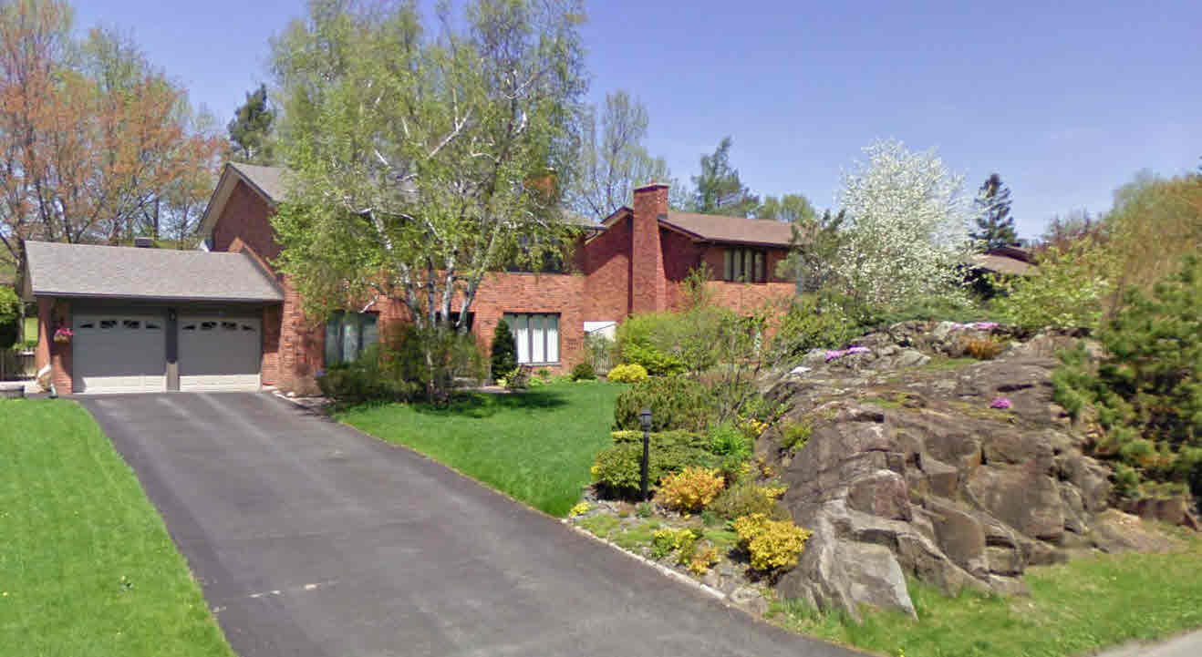
Tiffany

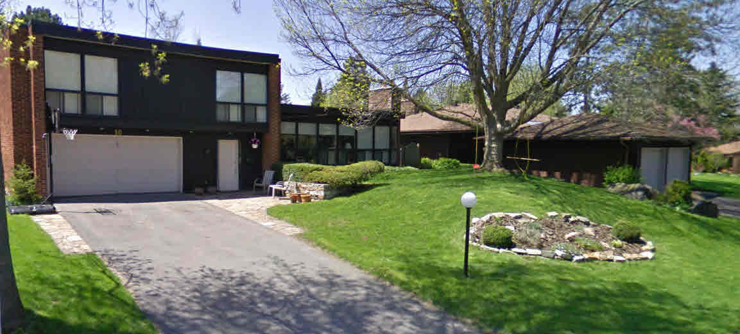
Leacock

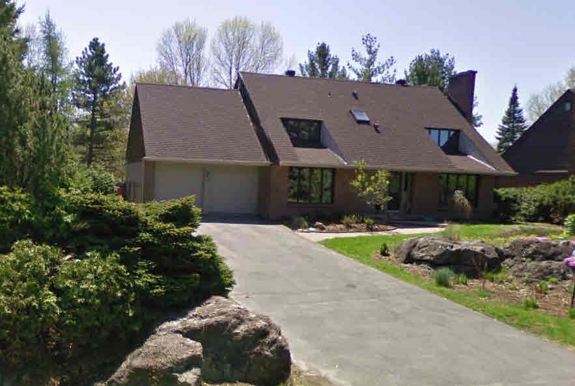
Pentland
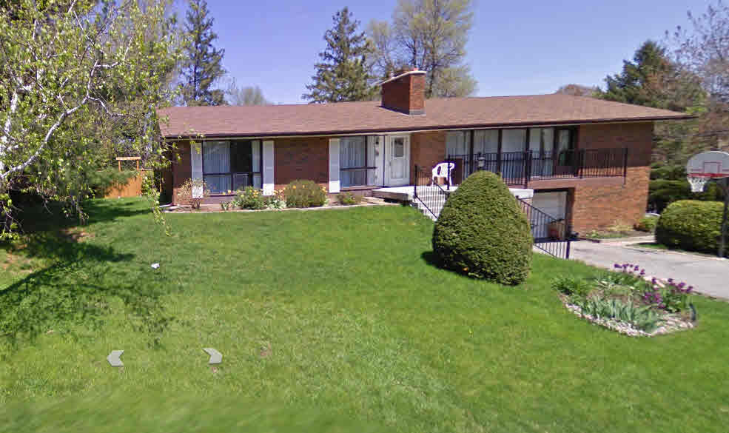
Pentland
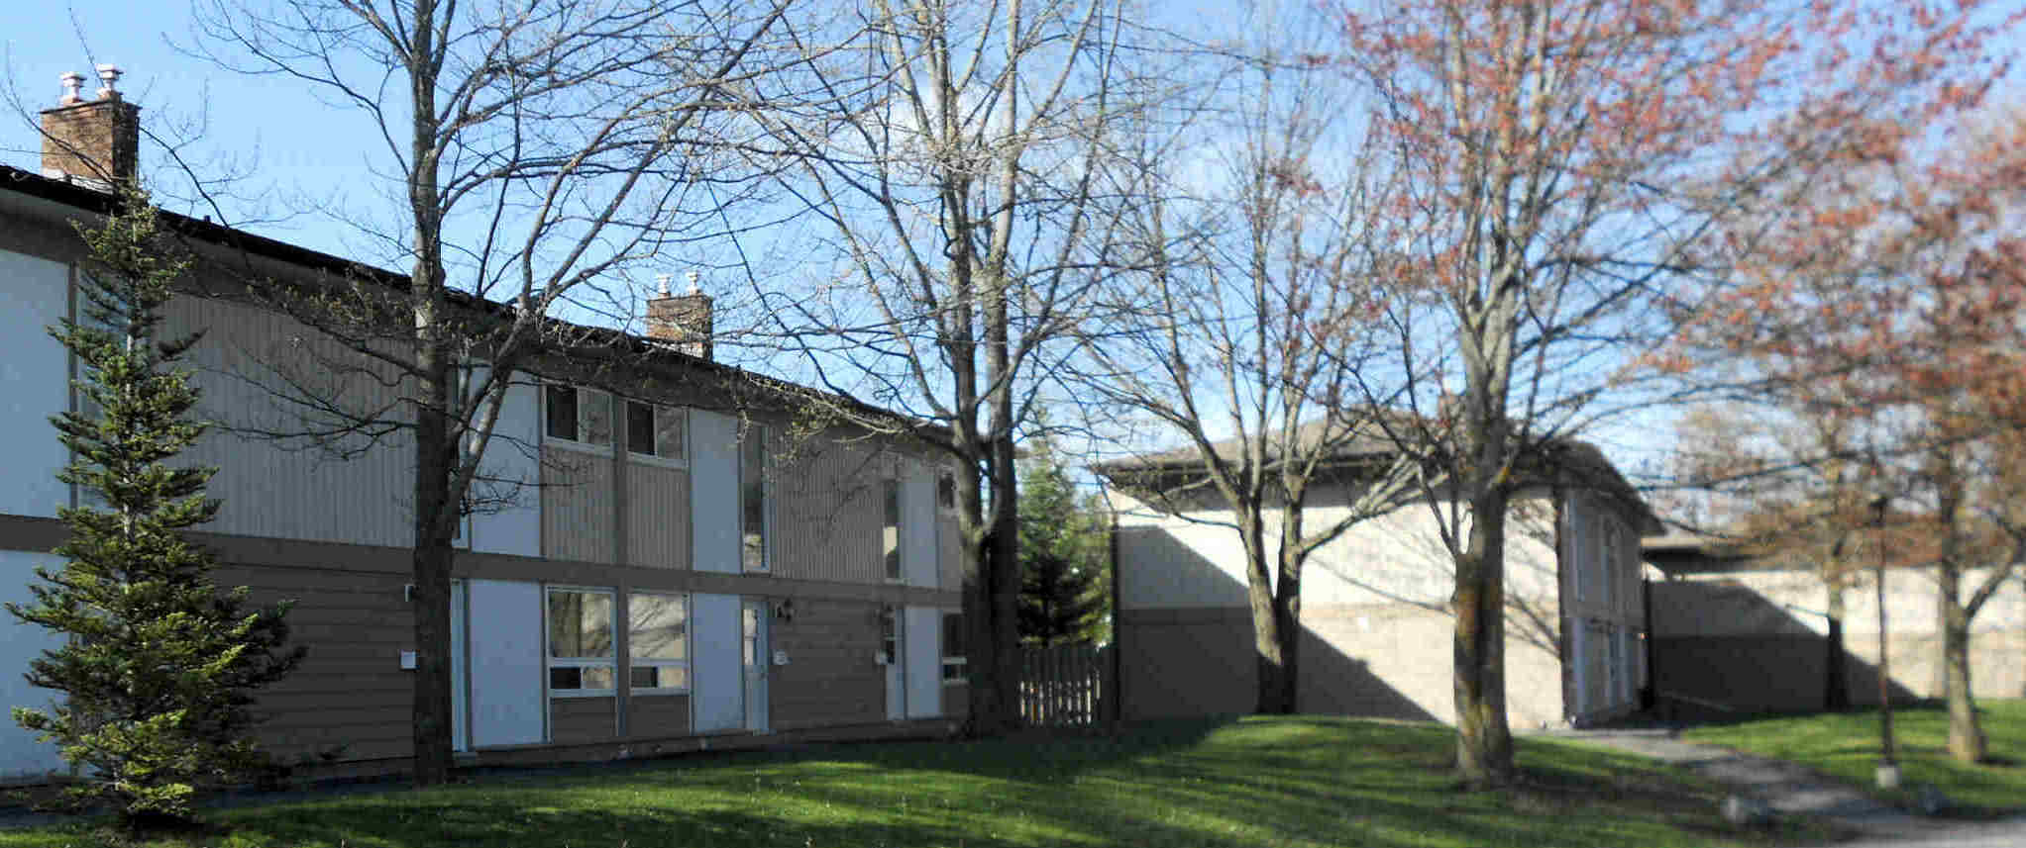
Varley – multi-family 2 story homes.
Low rise buildings and Apartments
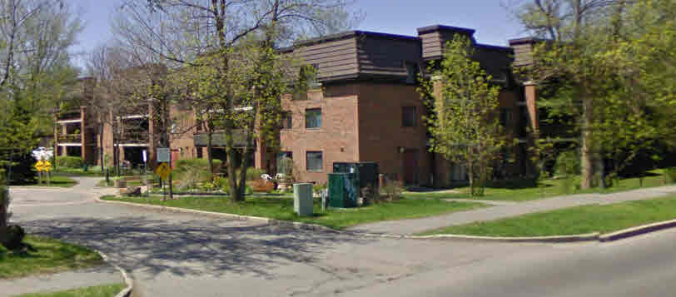
The Coop apartments on Teron Road. Note that the brick and roof style match mansard roofs used throughout Beaverbrook.
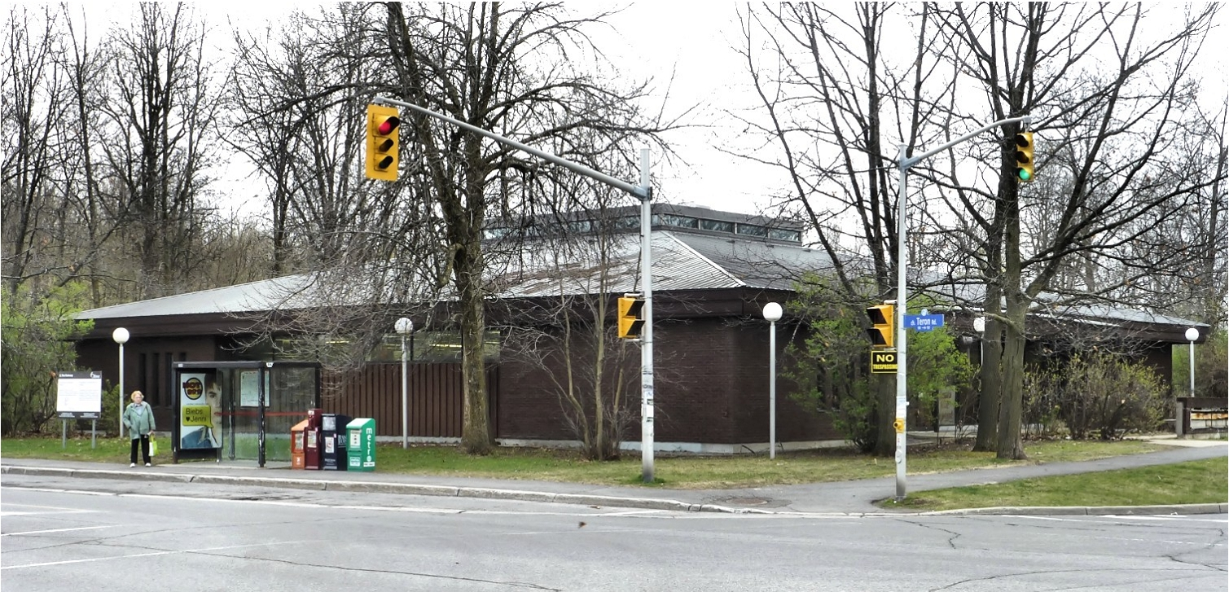
The post office currently existing on the 2 The Parkway site is an example of compatible architecture, with the standing seam brown metal roof, low roof pitch, large eaves and use of cedar and brick. This resembles many of the single story single family homes in Beaverbrook.

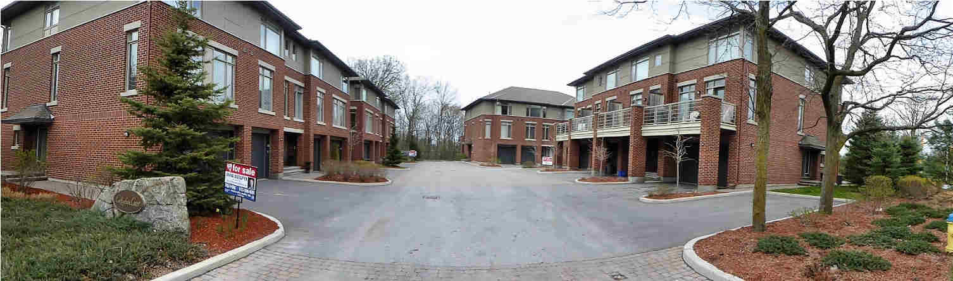
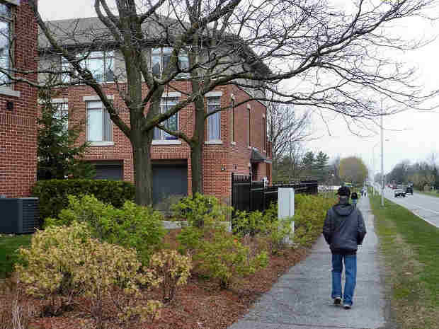
This is Callahan Court, which the community considers
incompatible in design and visual layout. Brick is used,
but roof shape and other elements do not match existing
Beaverbrook buildings.
In addition, the set back is a minimal 12 meters from the
curb, in stark contrast with other buildings on Teron Rd.
There is also minimal green space on the site, existing
only between the curb and buildings on both The
Parkway and Teron.

Large Buildings
Before providing examples of Beaverbrook larger buildings, it helps to understand examples of Frank Lloyd Wright’s larger building architecture and design

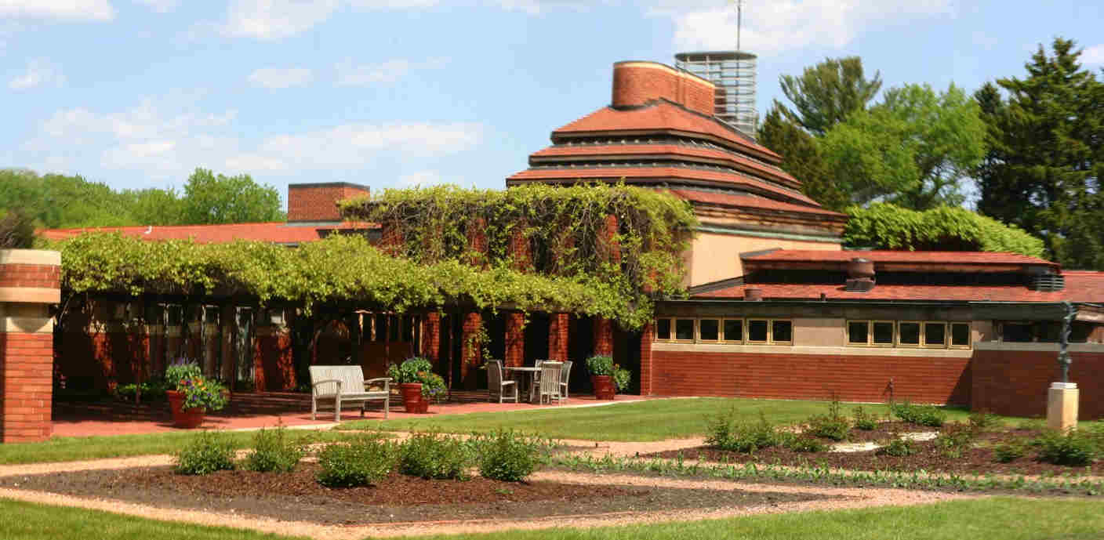
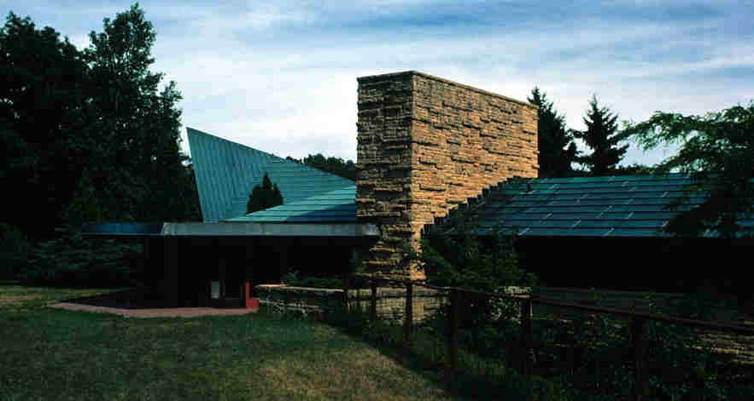
Unitarian Meeting House Wingspread
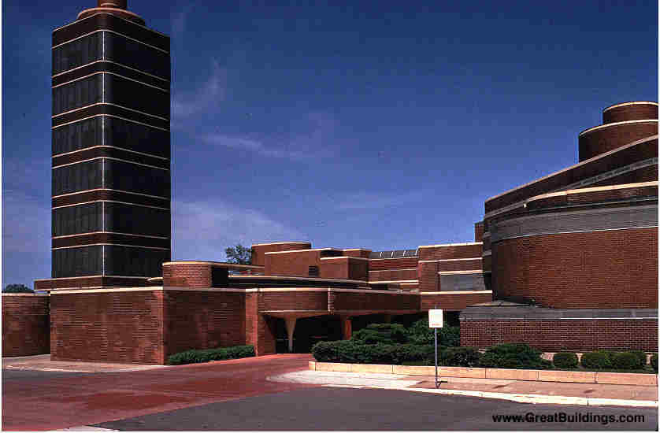
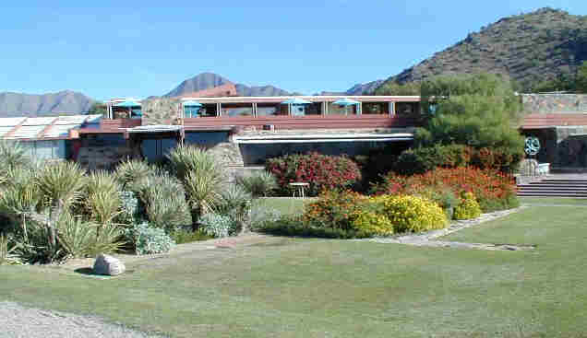
Taliesen West Johnston Wax Building

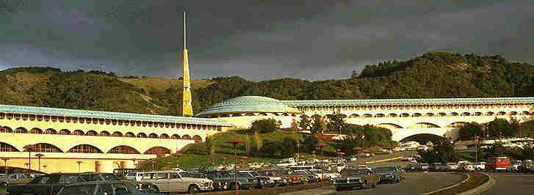
Marin Civic Center
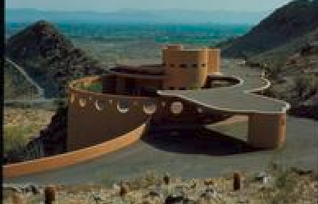
Aime and Normal Lykes House
Beaverbrook Examples
Note that the Stephen Leacock school picks up much of the elements and overall approach of FLW’s Unitarian Meeting House and Roland Michener does the same with the Johnston Wax Building and the Aime and Normal Lykes House
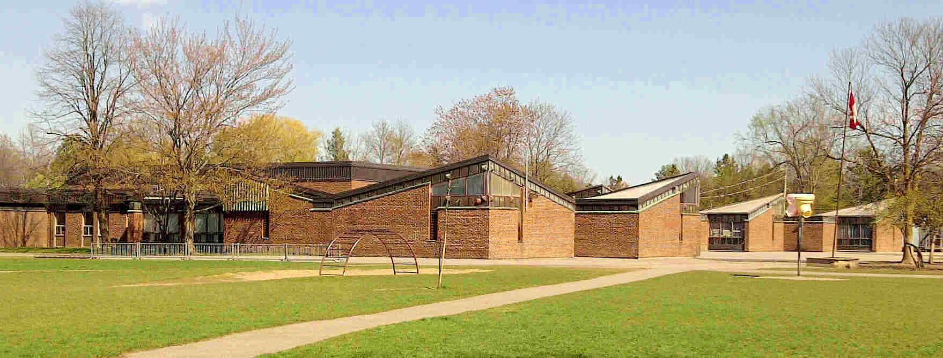
Stephen Leacock Elementary School
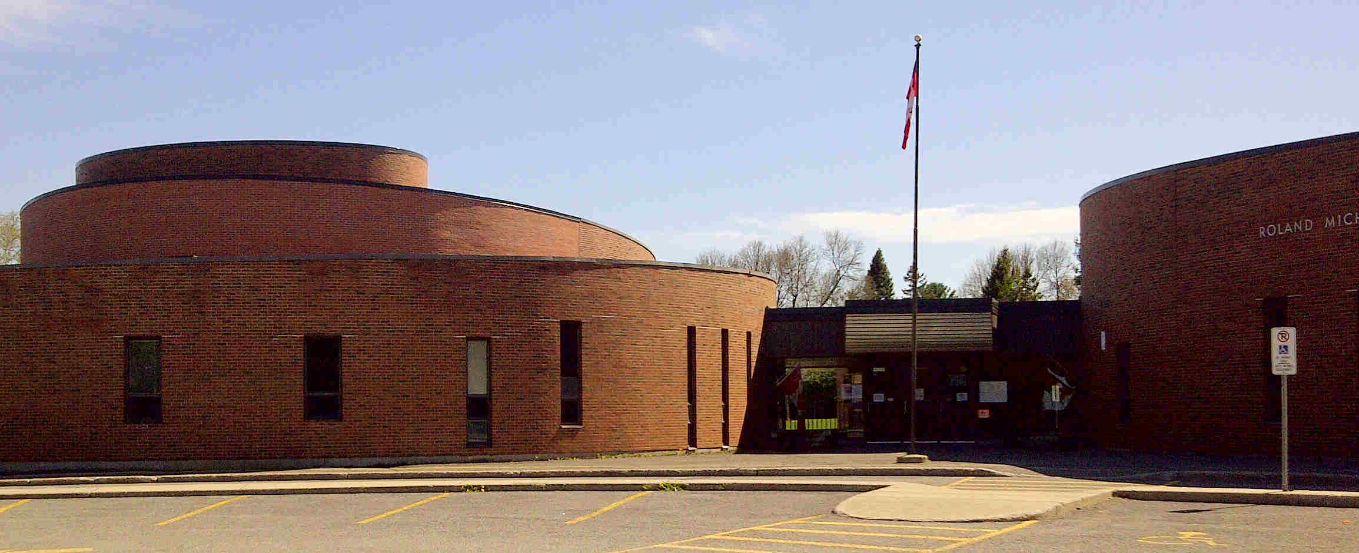
Roland Michener Elementary School
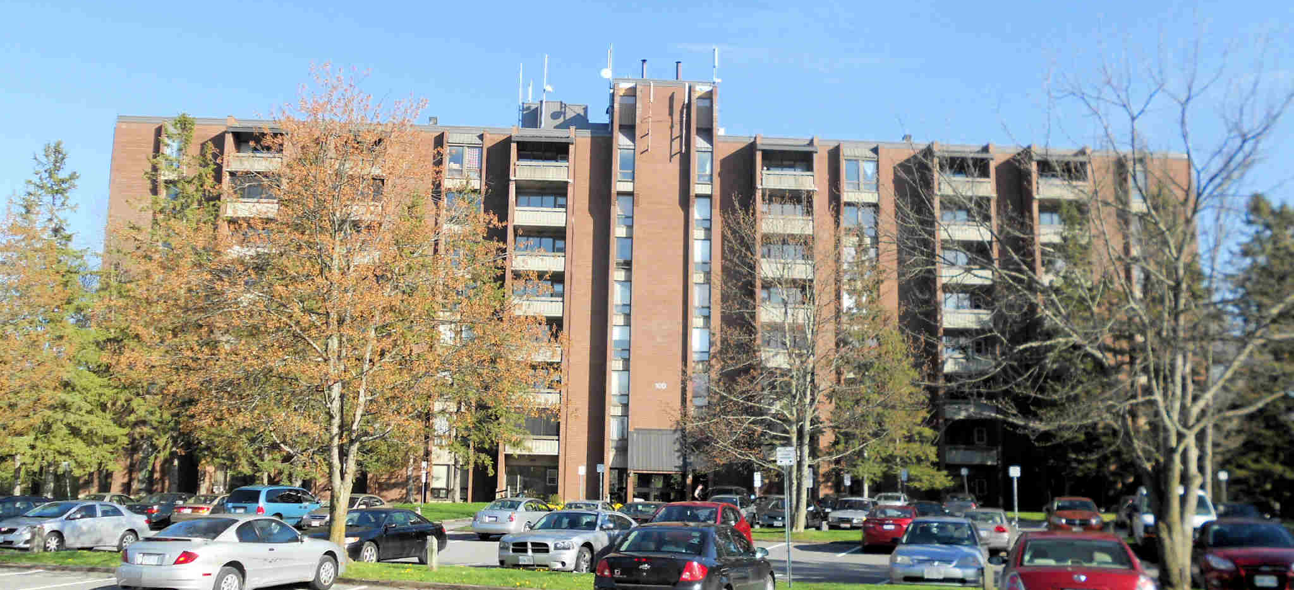
Varley Apartments – note that these are across from the multi-family homes shown earlier. The separation distance is 80+ meters.
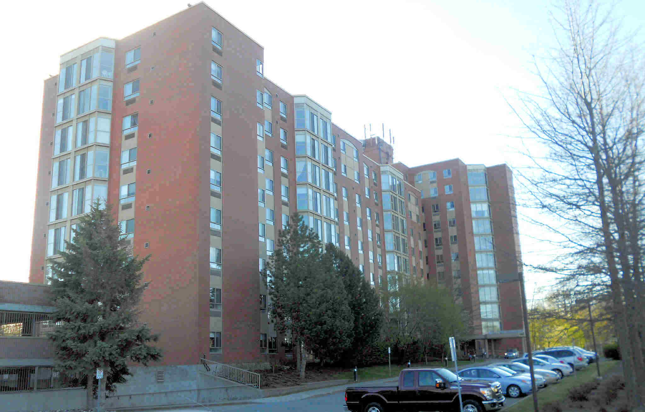
The Atriums Condominiums: note the extensive set-back, urban forest screening, designed gardens announcing arrival, at home.

1131 Teron
With the examples shown above, it is clear that the 1131 Teron proposal, here showing the model, plus a photo of a very similar and recently built building 1175 Maritime Drive in the Kanata Town Center, is incompatible in design, layout, size, height to setback proportion or materials and colours with the Beaverbrook character.
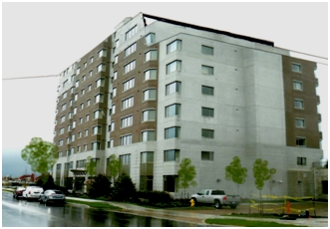
1175 Maritime Drive

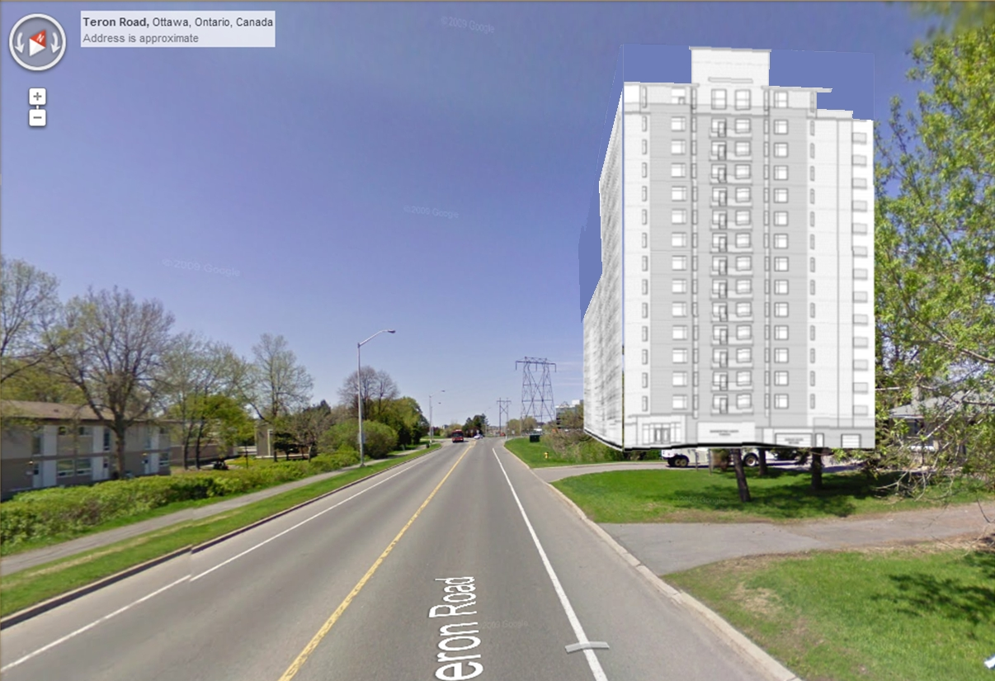
1131 Teron Drive – perspective mock-up, based on relative size of the 10/15 story height, relative as-built buildings, road width and curb-setback of the proposal
Green Space
Along with building architecture and design, it is important to understand the relationship of buildings to open and green space. Two illustrations: sample streetscapes and green space for two largest buildings in Beaverbrook – the Atriums and the Varley Apartments.
Streetscapes
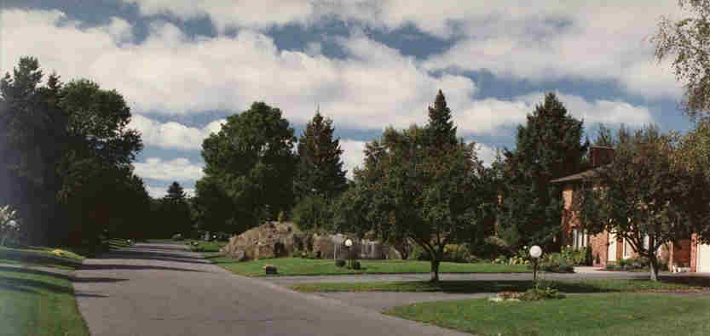
The above is a view of Tiffany Place – a street of single family homes – note the large rock outcropping in the middle of the picture (a feature on many Beaverbrook front lawns).
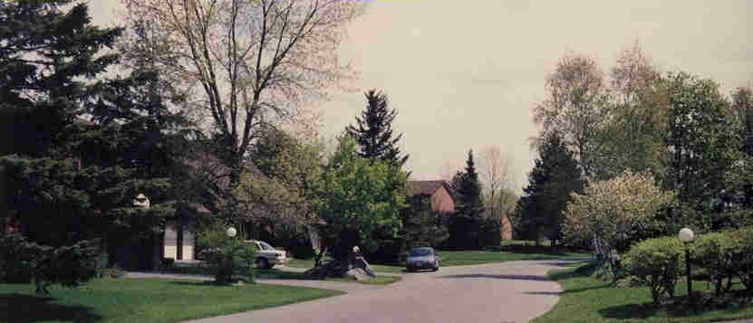
The above is a similar view – of Pentland Crescent

Large Building Green Space
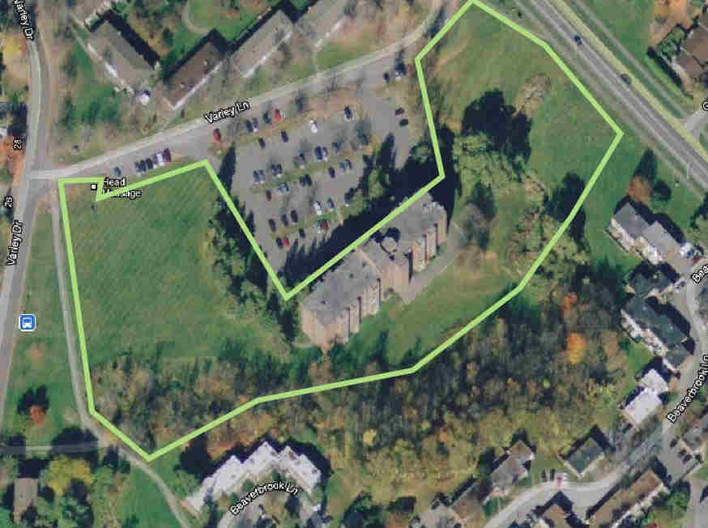
Varley Apartments
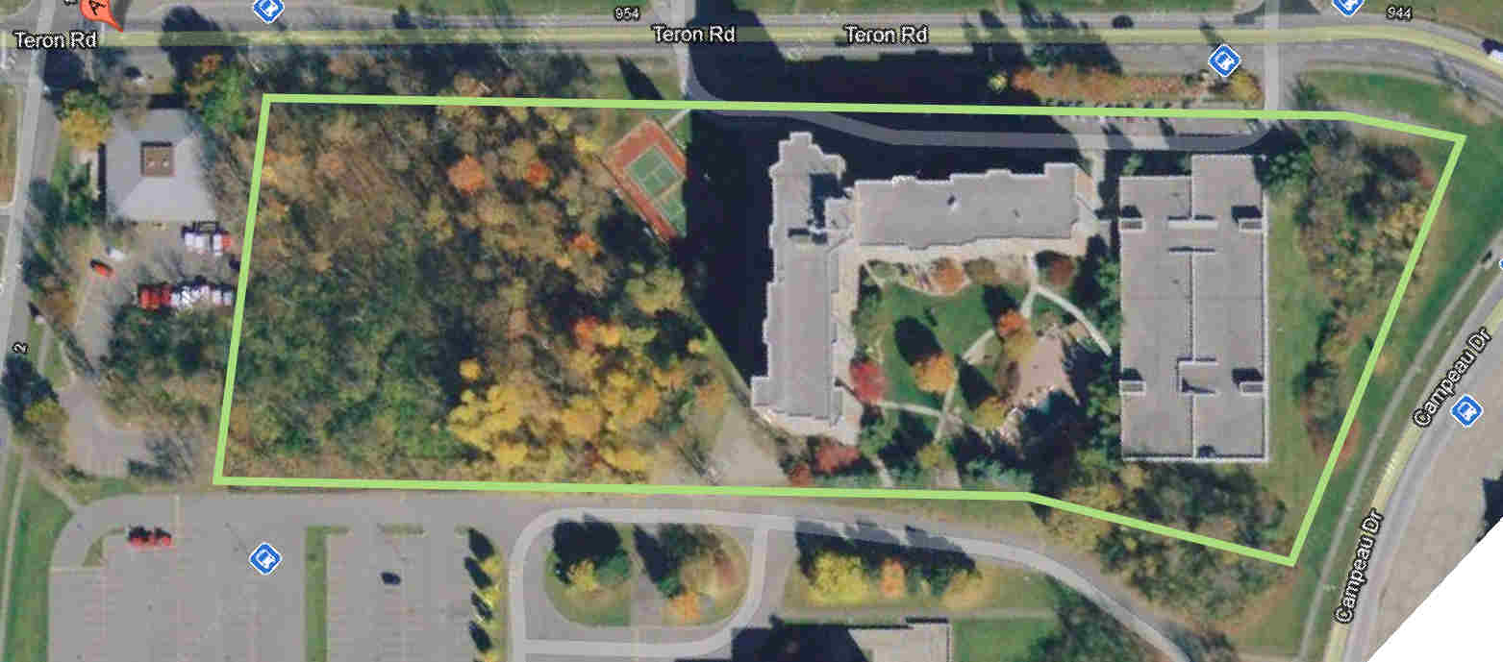
Atriums – note that the Atriums condominium corporation owns the forested land to the left of the building

